**Chameleon – MOP Web Design**

**WIREFRAME:**

**Purpose:**

The primary goal of this wireframe section is to serve as a structural guide for the website that showcases **Chameleon Website** work and their research contributions. The wireframes represent the skeletal framework of the website, focusing on the arrangement of elements and the functionality of each page, without delving into the visual design details like color schemes, fonts, or final graphics.

This document aims to:

* **Facilitate Communication:** Provide a clear reference for designers, developers, and stakeholders, ensuring everyone has a unified understanding of the website’s structure and functionality.
* **Guide Development:** It provides a blue print for the development team to outline the structure of the webpage and placement of the elements on the website, navigate flow, and provide interaction components of each page.
* **Optimize User Experience:** Focus on creating a user-friendly experience by considering the logical flow of information and the accessibility of key features throughout the website.

**Scope:**

The scope of the wireframe section covers all the pages and functions of the Chameleon website. The following are the pages for the wireframes:

* **Home Page:** The landing page provides the introduction of the website, Vision of the company , recent case studies.
* **About Us Page:** The page provides the details regarding information about team policies, leadership and mission of the website.
* **Case Studies Page:** The page provides information regarding the case studies allowing user to browse the available work visually. This page also have the feature to search for particular case studies.
* **Statistics Page:** The statistics page features graphical representation of data related to submission and user engagement. The design provides clarity using simple charts and graphs.
* **Contact Us Page:** The Contact Us page includes a simple form for user inquiries to the organization.
* **Licensing and Privacy Policy Page:** The page provides the necessary user about the company rights and handling practices for the data.
* **User Authentication Page:** SignUp, Login, Forgot Password, and OTP Verification pages which handles the user’s registration, login and account recovery process.

Each wireframe within this documentation provide details layout of the webpage and key features, and user interface. The documentation does not cover the final visual design elements such as colors, typography, or detailed graphics content.

**Wireframe Pages:**

The below wireframe explains about the detailed version of design done on the each page. This provides the blueprint and development progress. The outline the structure, layout, and key functionalities of each page, providing a clear visual representation. These wireframes are early stage development, allowing stakeholders to review and approve the design.

1. **Home Page:**

**Description:** The current page provide the overview of the company and help users to understand the company’s missions. Also provide the recent cases for users to browse more conveniently.

**Key Features:**

* Provide users to sign in or sign up.
* Provide the introduction for the MOP’s vision.
* Provide recent case studies for users to browse.

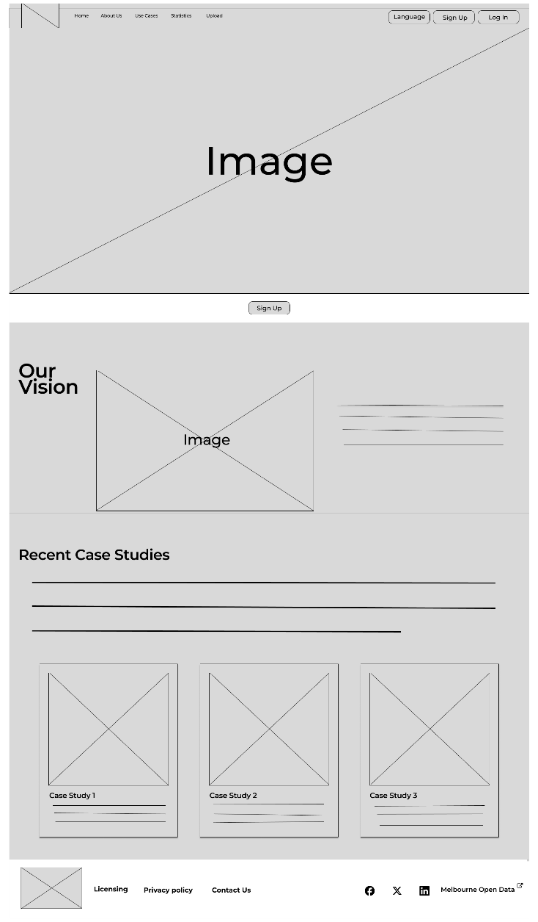

1. **About US Page:**

**Description:** The About Us page provides information about the company and helps users understand the objective of the goals which this will provide for them. It will also provide information about the City of Melbourne and what Open Data is about.

**Key Features:**

* Information which allows users to understand who MOP are.
* Provide history of where this project aligns.
* Give insight of what The City of Melbourne is about and their goal.

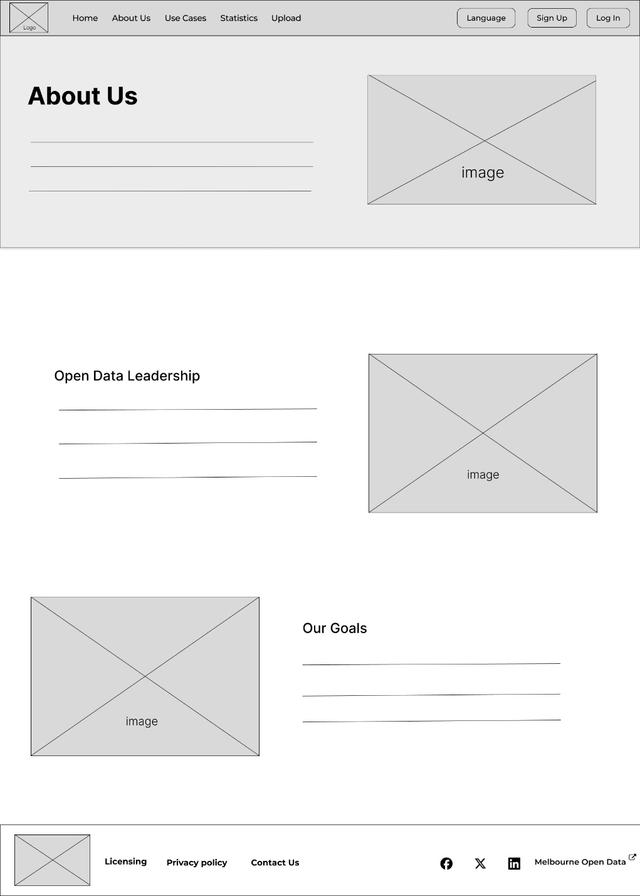

1. **Case Studies Page:**

**Description:** The current page provides the details of each case studies done by the data science team. Each case studies is represented by a visual card and all the case studies are organized into a grid layout.

**Key Features:**

* A search bar for a quick access to specific case studies.
* A filter or category option to organize the case studies.
* A grid layout which shows the all the uploaded case studies page.
* Clicking on case studies will open to the new page showing it details.

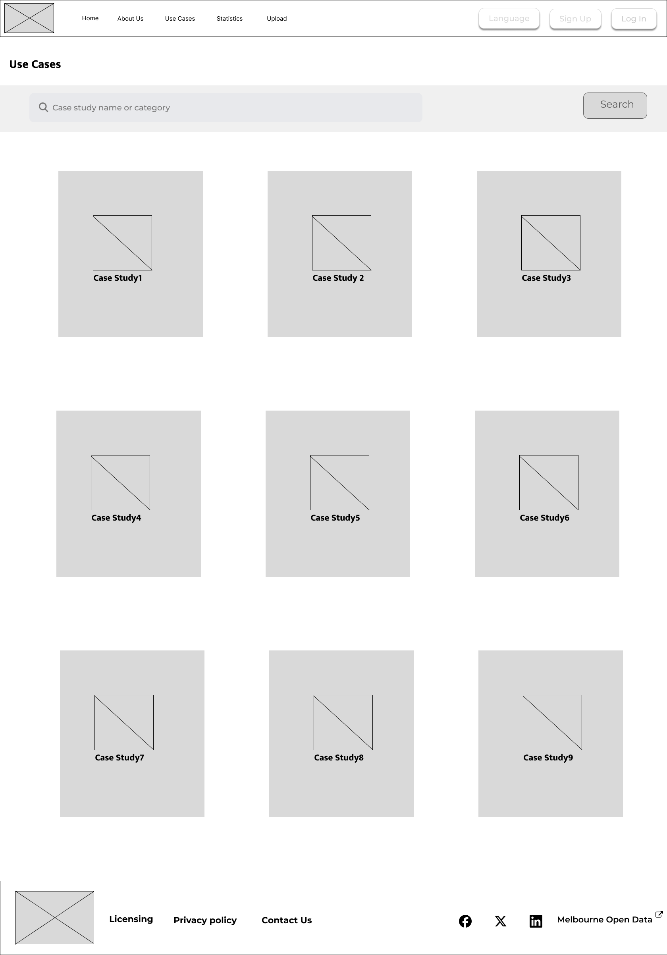

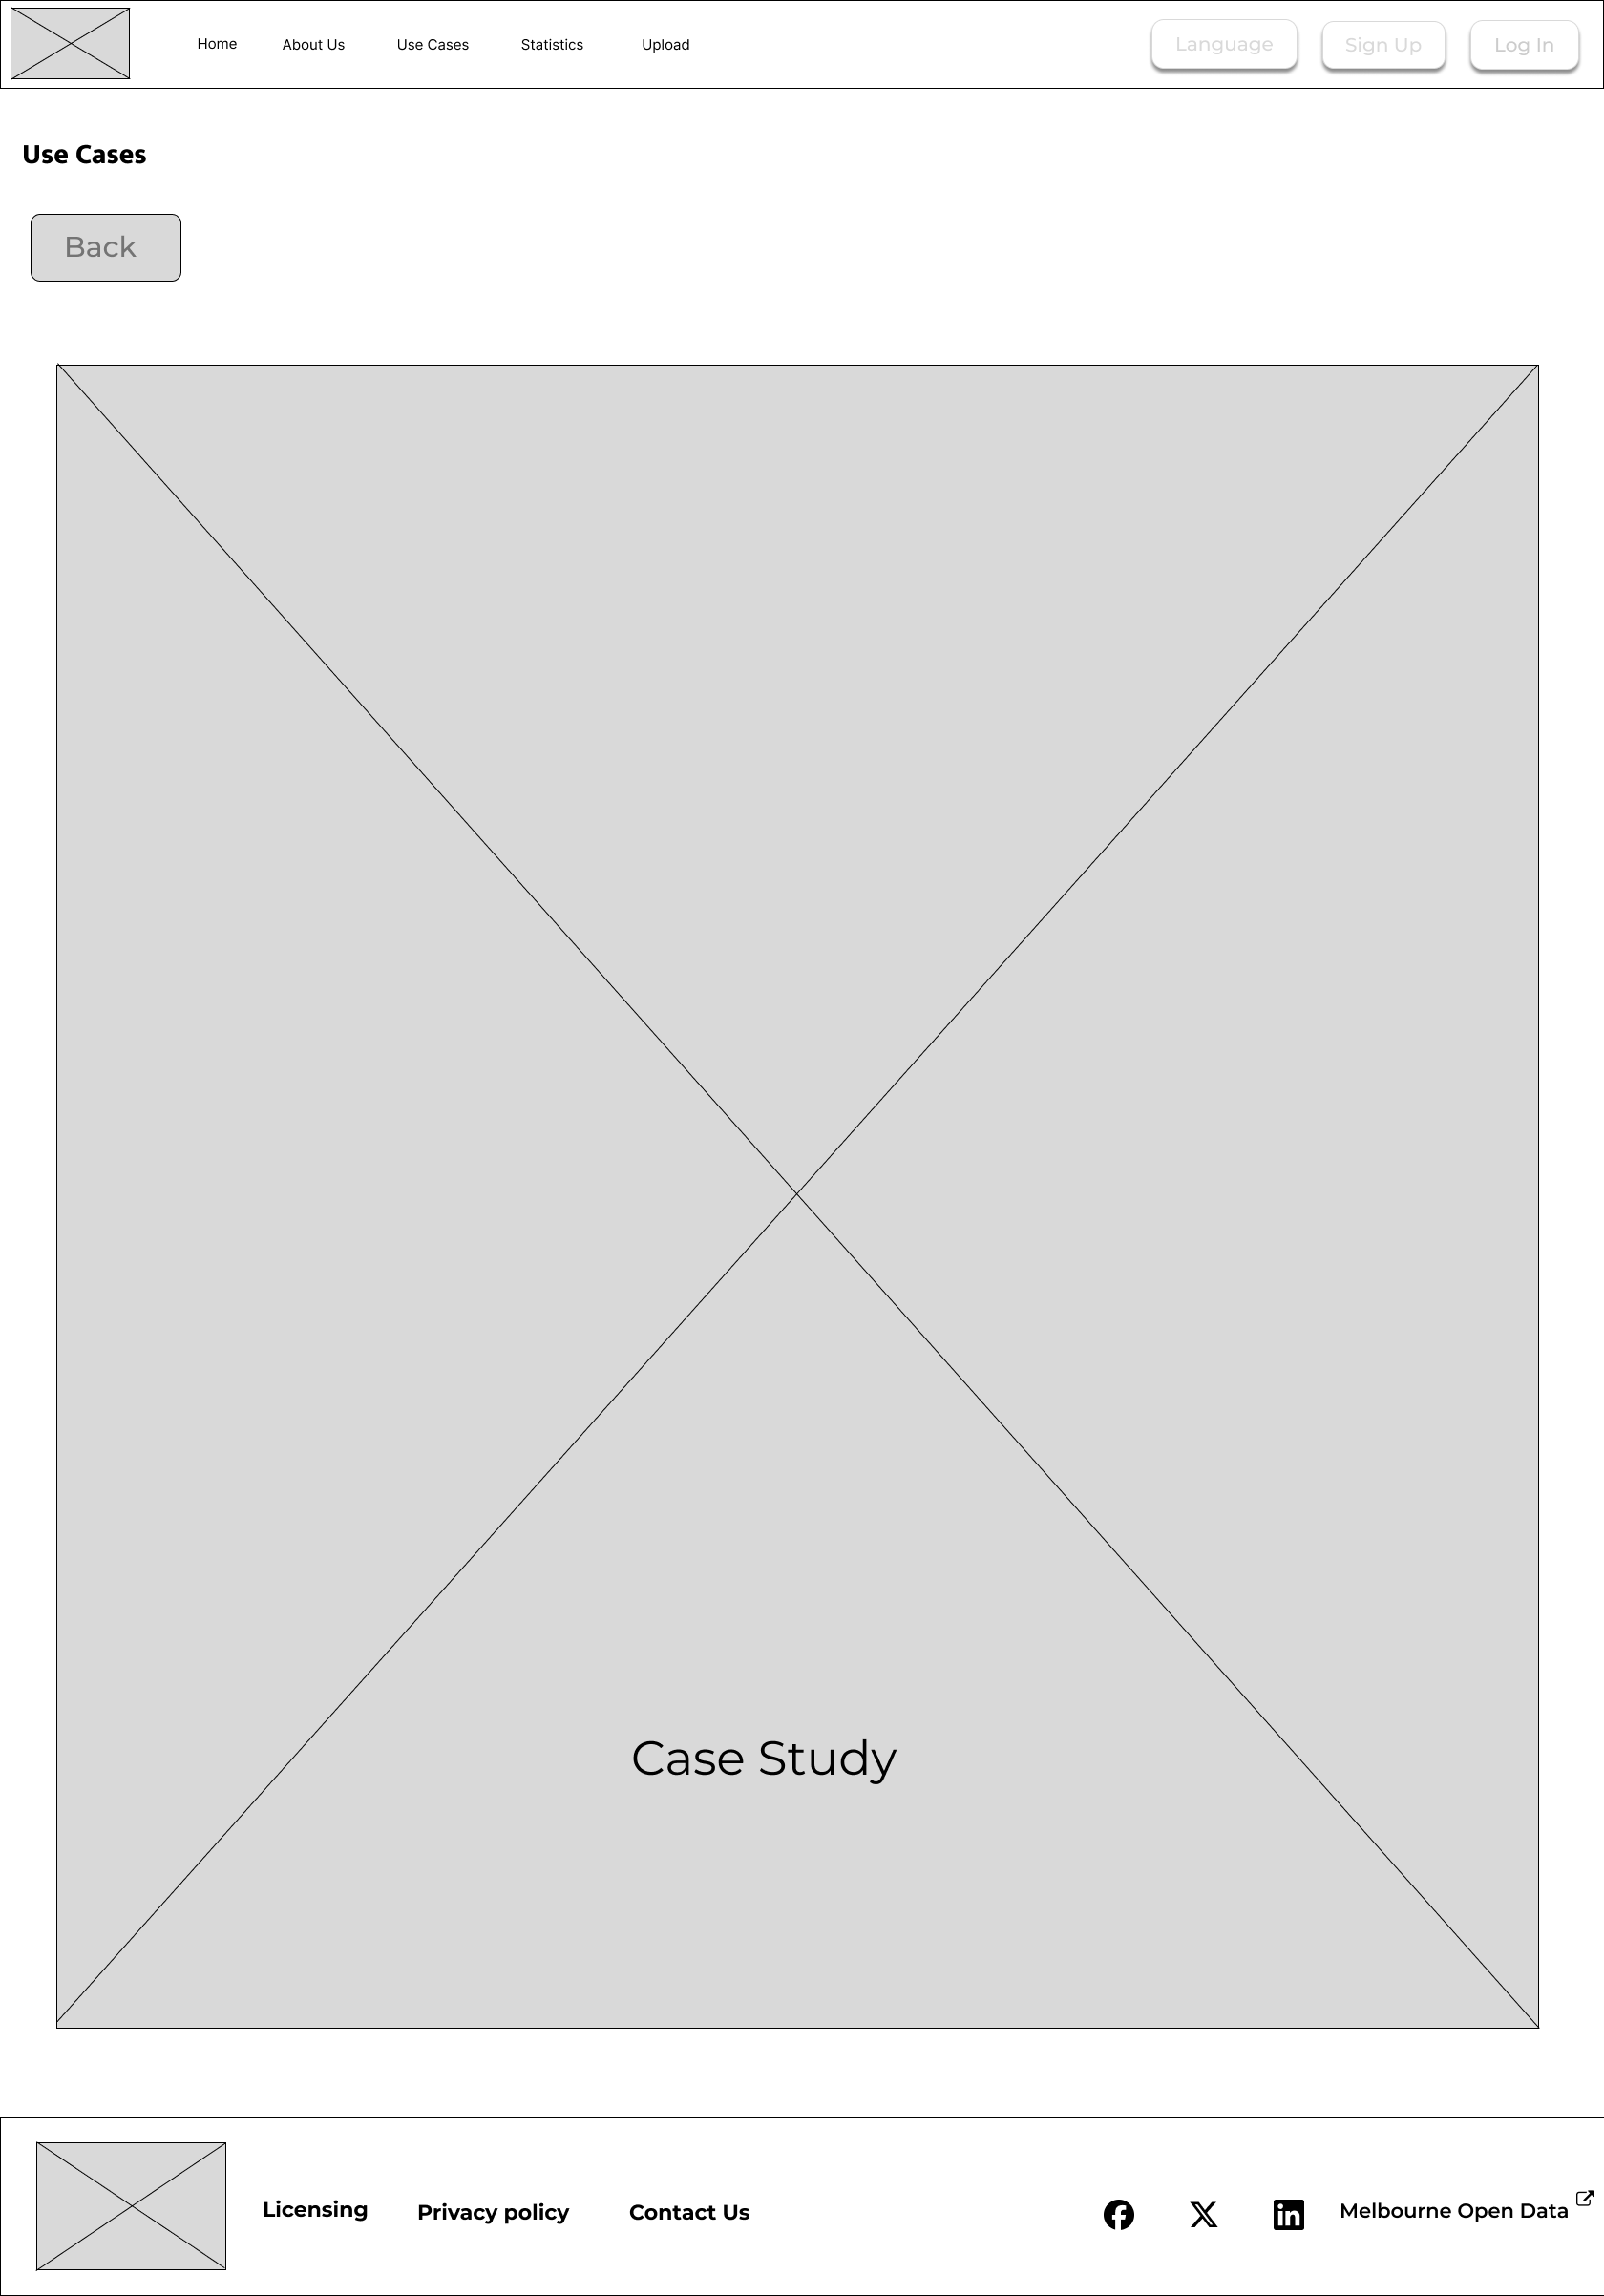

1. **Statistic Page:**

**Description:** The Statistics page provides a comprehensive overview of the data related to "published test cases" organized by tag. It features a bar graph that highlights the "Trimester which published the most test cases." Users can also utilize filter options to refine their search results based on specific tags and criteria. This page is designed to give users a clear visual and tabular representation of the test cases, facilitating quick insights and easy data navigation.

**Key Features:**

* **Bar Graph:** A visual representation of the "Trimester which published the most test cases," allowing users to quickly identify trends and patterns across different trimesters.
* **Filter Options:** Provides users with the ability to filter test cases based on specific tags and other criteria, ensuring that the search results are tailored to the user's needs.
* **Results Table:** Displays the filtered test cases in a structured table format, with each test case presented as a row. This table allows users to easily review and analyze the data.

**Wireframe:**

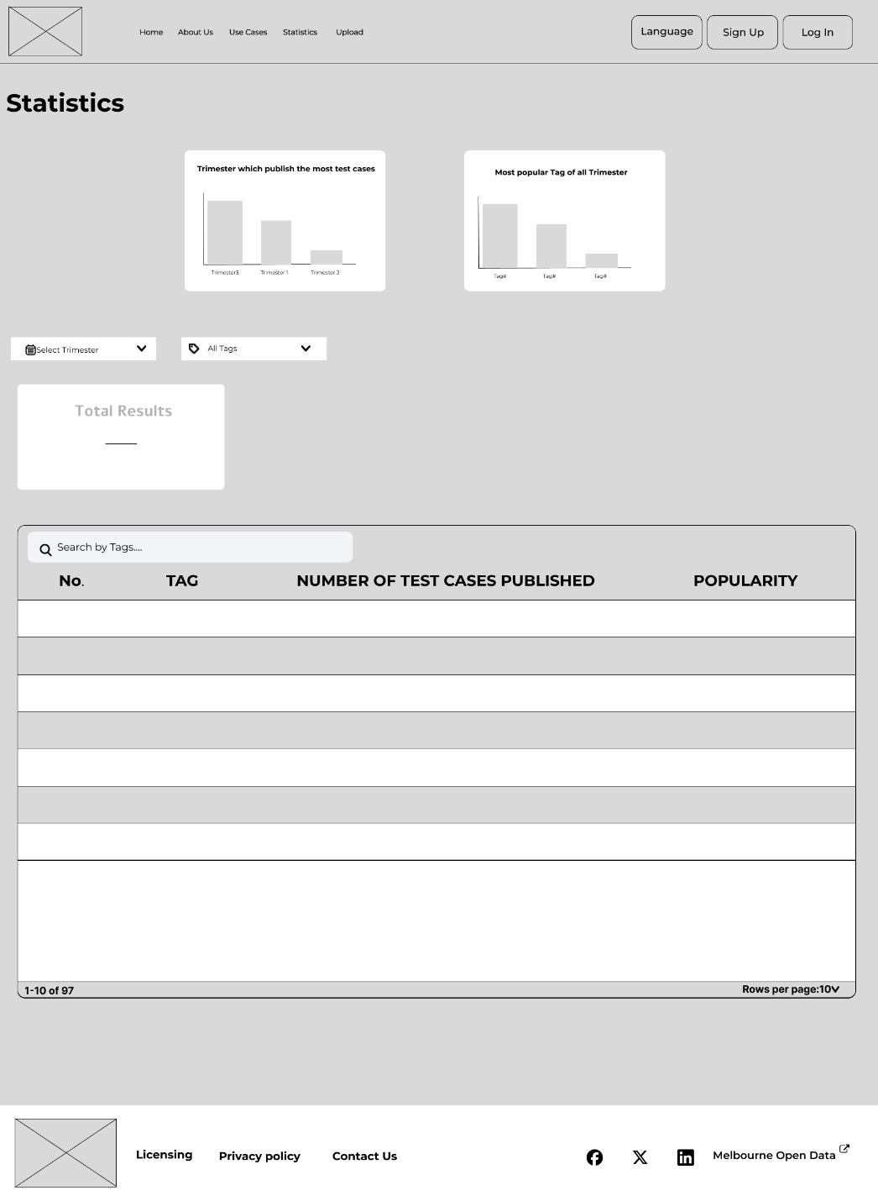

1. **Contact Us Page:**

**Description**: The Contact Us page allows the user to contact the organization’s support team for any business or personal enquiries. This page can be accessed from the website’s footer.

Key Features:

* Personal Information Input: The user must input their first name, Last name, email address and phone number
* Message Input: In that chat box, the user can write their message for the support team and outline anything they want to discuss with them
* Submit: The submit button will submit the message and the user will get a reply from the support team in their email or phone number
* Organization Image on the right side of the Contact Us page

**Wireframe:**

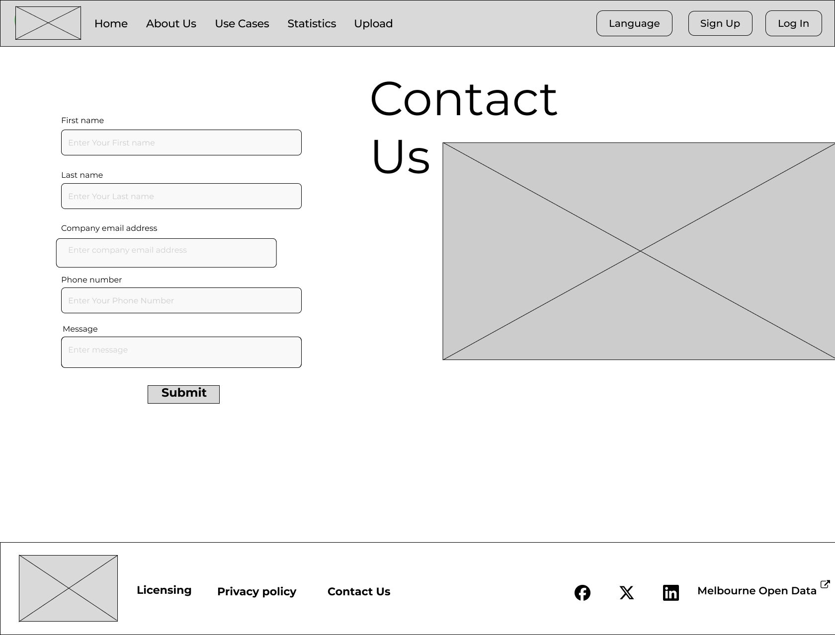

1. **Case Study Upload Page**

**Description:** The "Upload Case Study" page is designed to facilitate the process of uploading case studies. Users are required to fill in specific details through provided text boxes, ensuring that all necessary information is captured before submission. The page also includes a user-friendly "drag and drop files" section, allowing users to easily upload files associated with their case study. A progress bar is prominently displayed to keep users informed of the upload status, showing the percentage completed as the files are uploaded.

**Key Features:**

**Text Boxes for Input:** Users must fill out text boxes with relevant information required for the case study upload, such as title, description, and any other necessary details.

**Drag and Drop Files Section:** This feature allows users to drag and drop their files directly into the designated area for upload, streamlining the process.

**Progress Bar:** A visual progress bar indicates the percentage of the file upload, providing real-time feedback to the user on the status of their submission.

**Wireframe:**

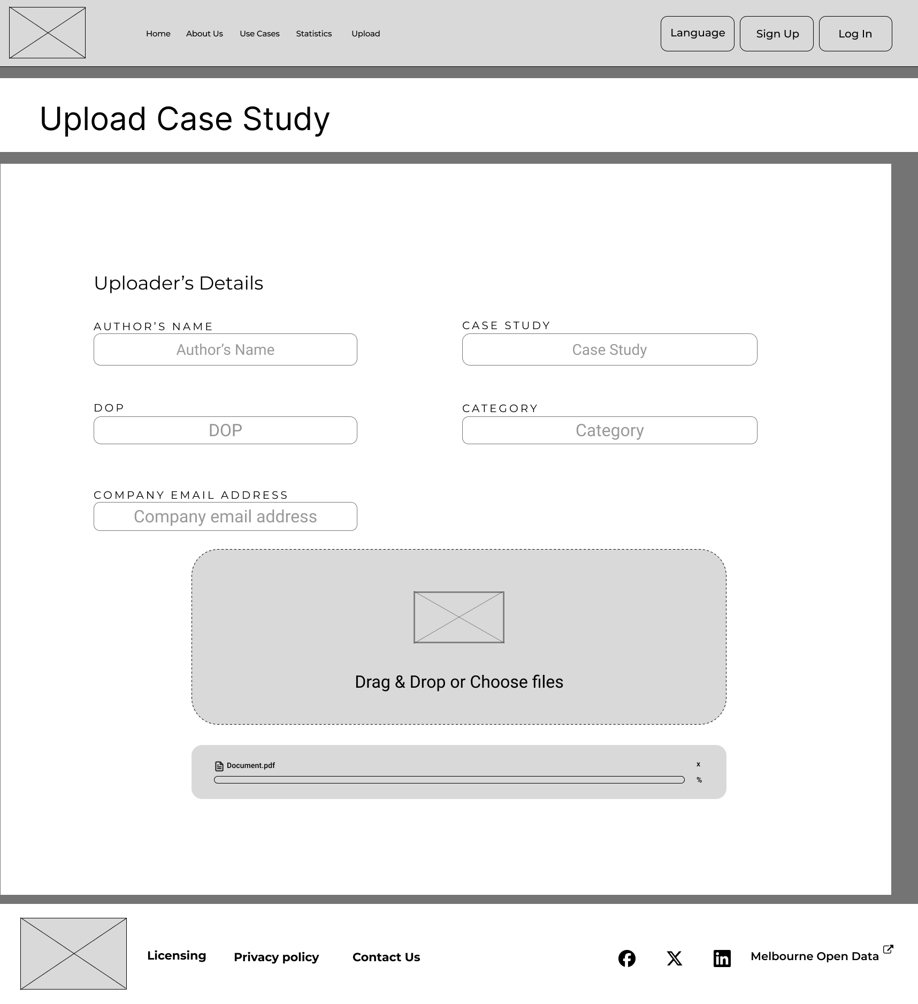

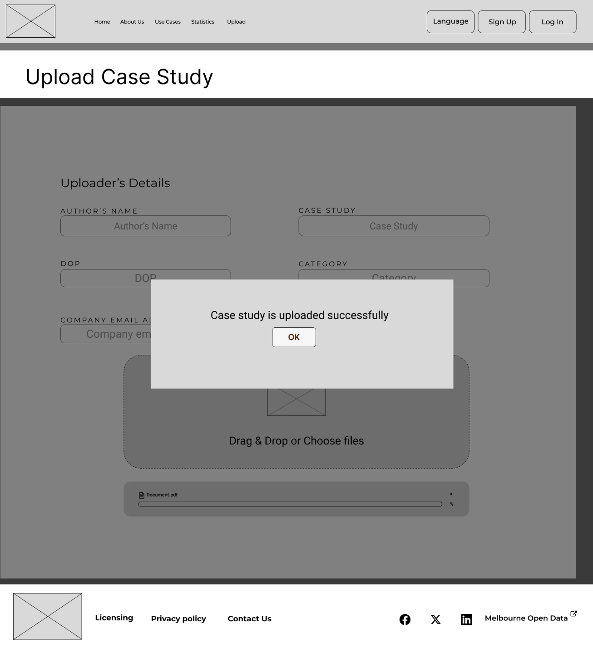

1. **Licensing Page:**

**Description:** The Licensing page informs users about the terms of use, intellectual property, and restrictions on the website's resources.

**Key Features:**

Terms of use specify user obligations, such as legal conformity and confidentiality.

Intellectual property defines ownership of content and prevents illegal use.

License Grant specifies the limited, noncommercial access allowed to users.

Restrictions specify a list of prohibited acts to ensure the website's integrity.

Termination describes the situations under which user access can be terminated.

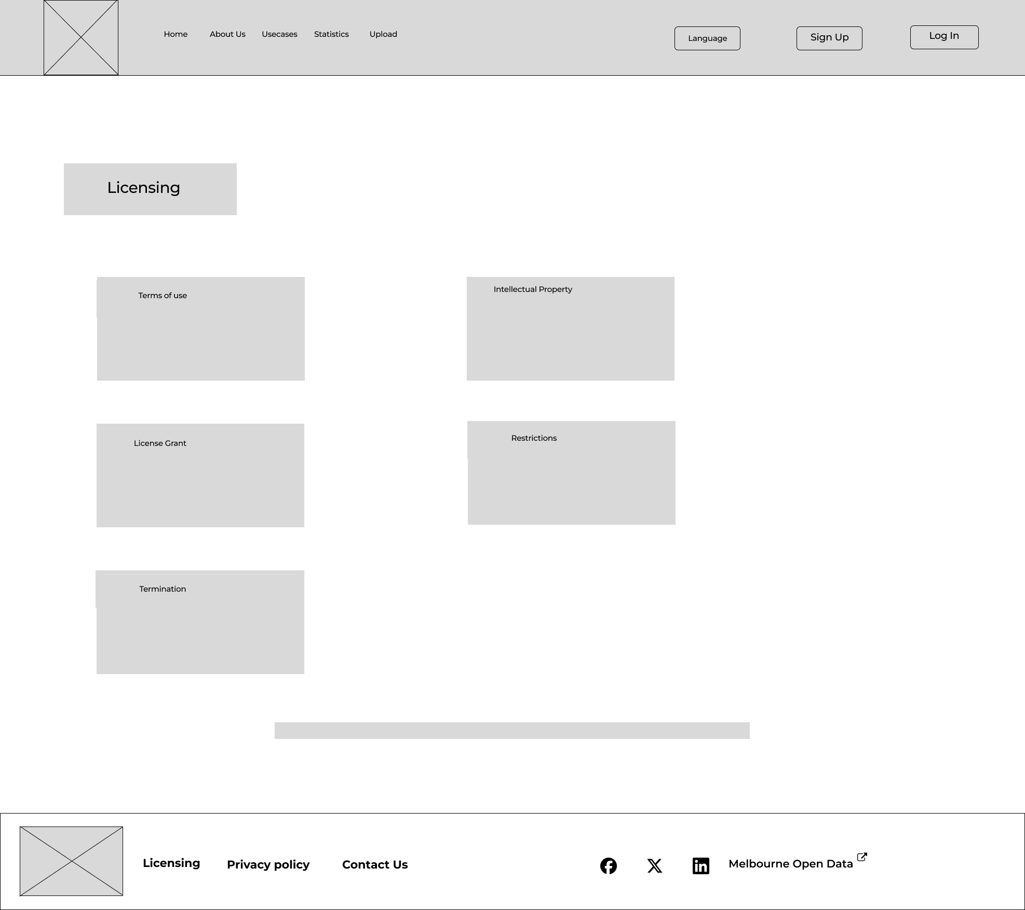

1. **Privacy Policy Page:**

**Description:** The Privacy Policy page shows users about data collecting, usage, and security measures, as well as the website's rules on cookies and third-party links.

**Key Features:**

Information We Collect describes the many forms of personal and non-personal data collected.

Use of Information describes how acquired data will be used while protecting user privacy.

Data Security describes the steps taken to protect user data.

Third-Party Links offers transparency about external links and their privacy standards.

Cookies explain how cookies are used to improve the user experience and provide the user with more control.

Policy Changes informs users about anticipated revisions to the privacy policy.

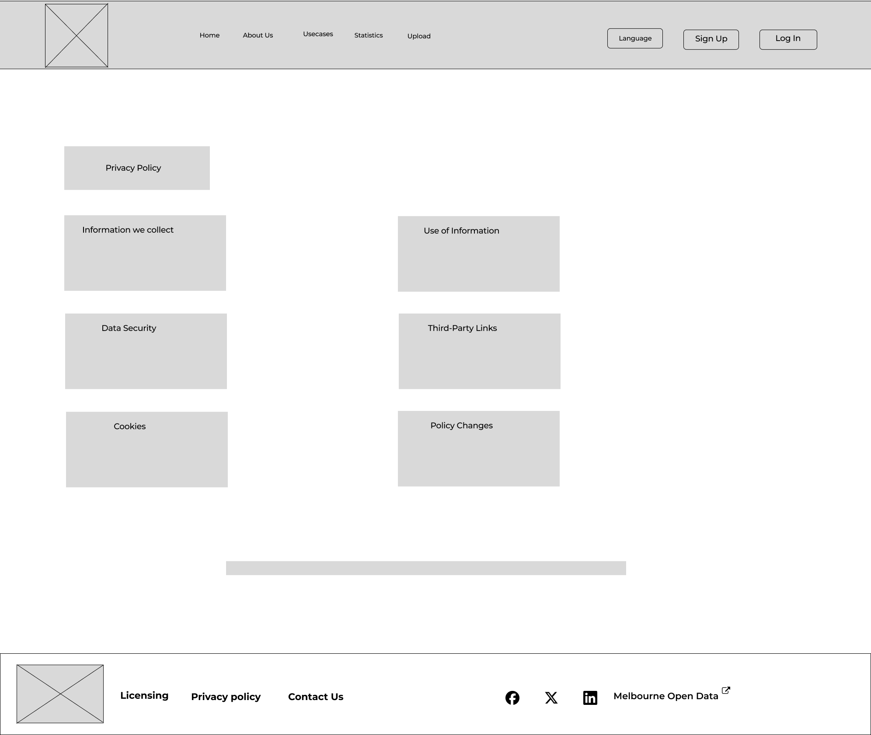

1. **Sign In Page:**

**Description:** The Sign In page allows users to log in to their profile for easy access to their saved details.

**Key Features:**

* Login credentials (email and password) are stored from the Sign-Up page and used to give users access to their profile.
* Remember me, the tick box is used to take permission from users to save their details in the browser for faster login.
* Forgot Password link is provided for the users to recover their profile if they don't remember their password.

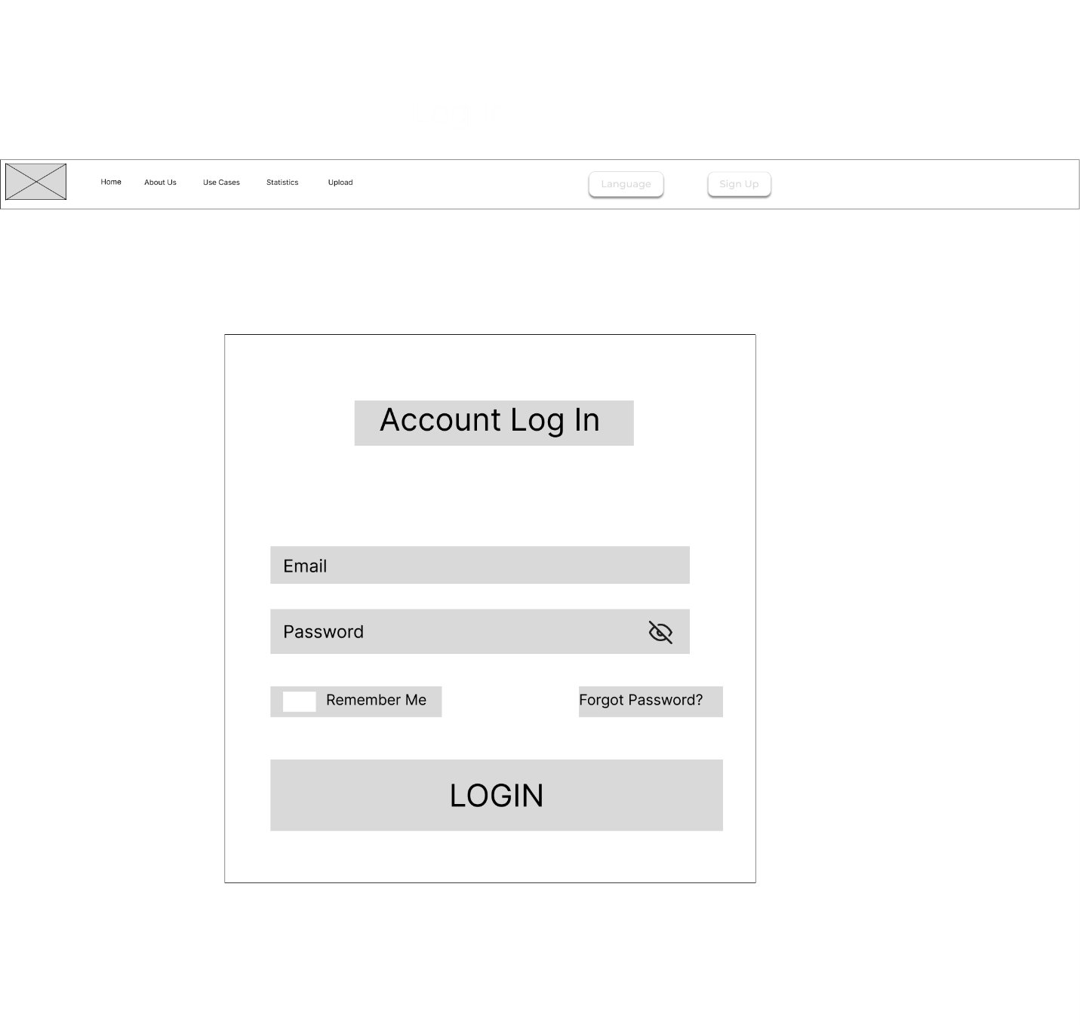

1. **Sign Up Page:**

Description: The Sign Up page allows a new user to set up their profile with Chameleon.

Key Features:

* Personal details of the new user like First Name, Last Name, Email Address and Password are captured and stored.
* Password Strength bar is present which would let the user know how strong their new password is, so that they can set up accordingly.

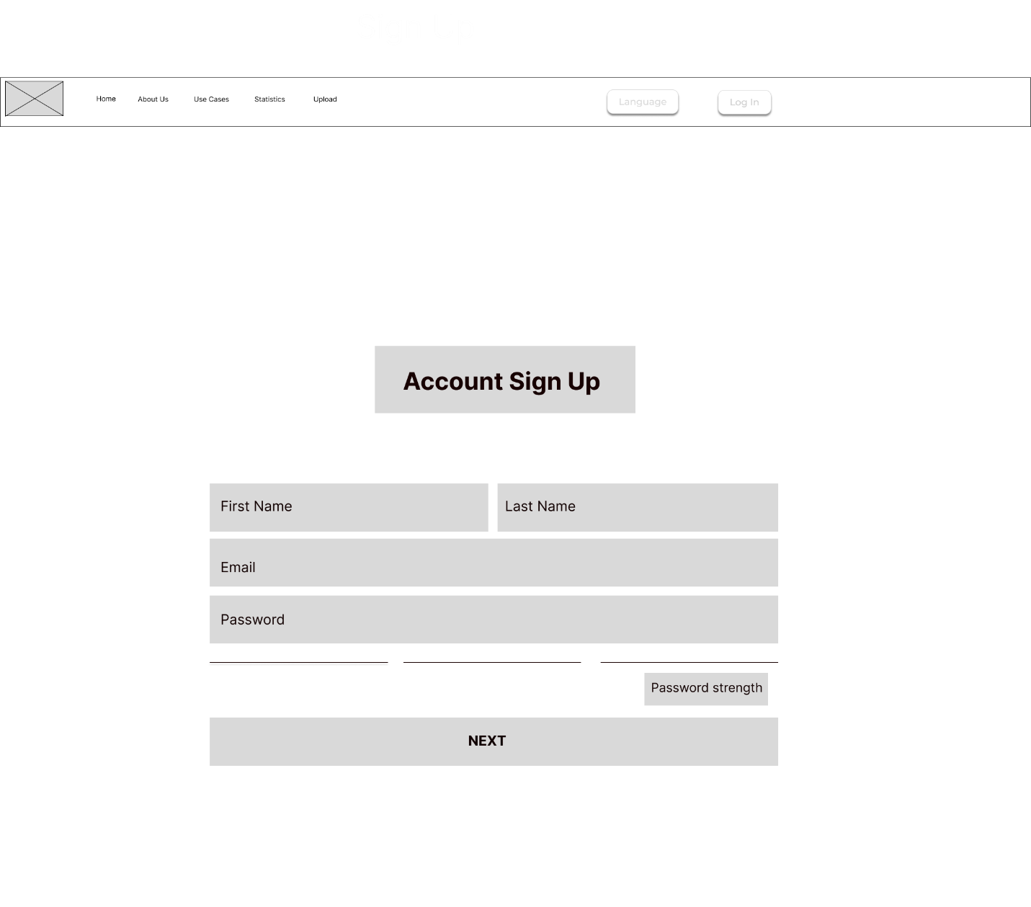

1. **Forgot Password Page:**

**Description:** The current page provides users with the chance to change their password if they forget. Users are allowed to enter their email address, then the user email address will receive the one-time password for validation.

**Key Features:**

* There is an input field for users to entre email addresses.
* There is a continue button for the user to go to the next step.

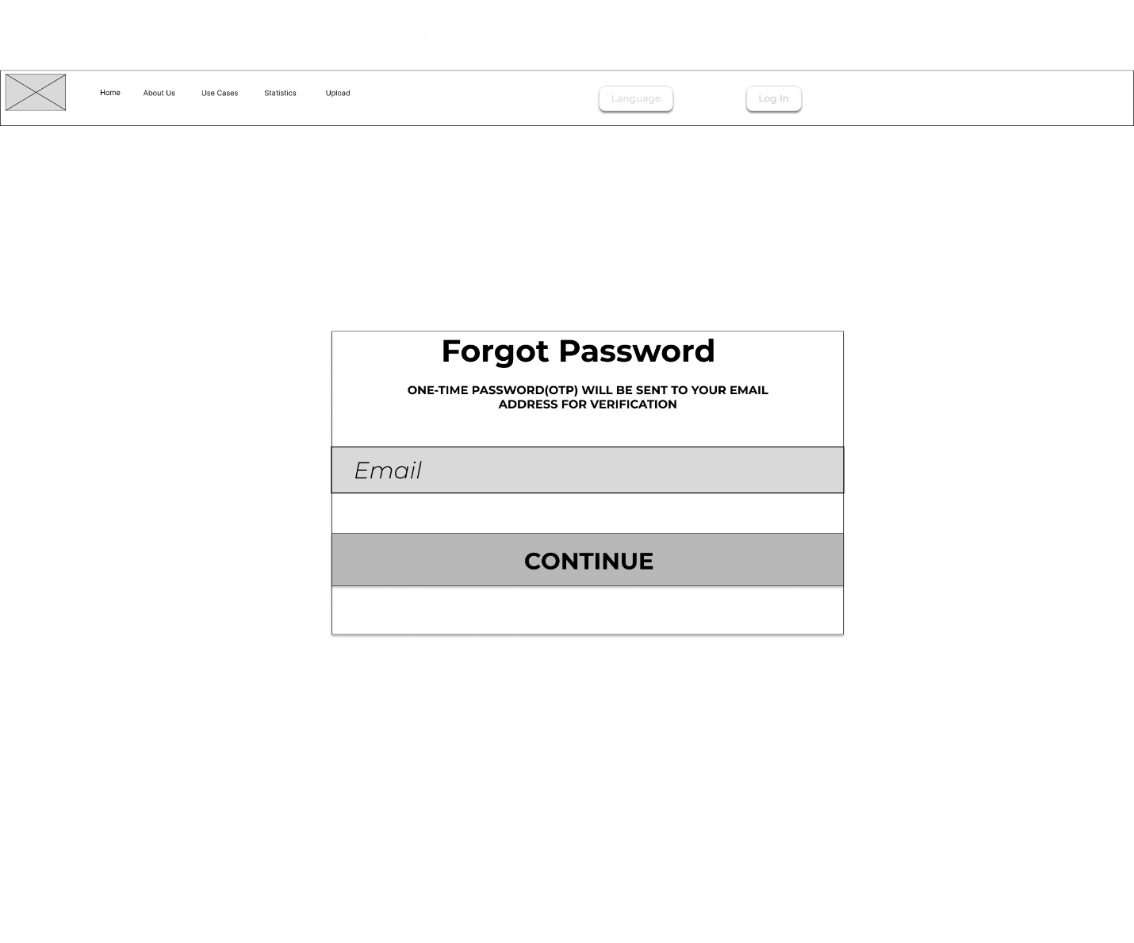

1. **OTP Verificaton Page:**

**Description:** The current page provides users with the chance to reset their passwords, once the user entre the one-time validation code and sets a new password and confirms the password. After that the user can successfully reset their password.

**Key Features:**

* The field for validation code input must be 4-digit code.
* The field for new password and confirm password have visible and invisible icon choose by users to see the password or not.
* There is password strength certification provided to support users to strengthen user account security

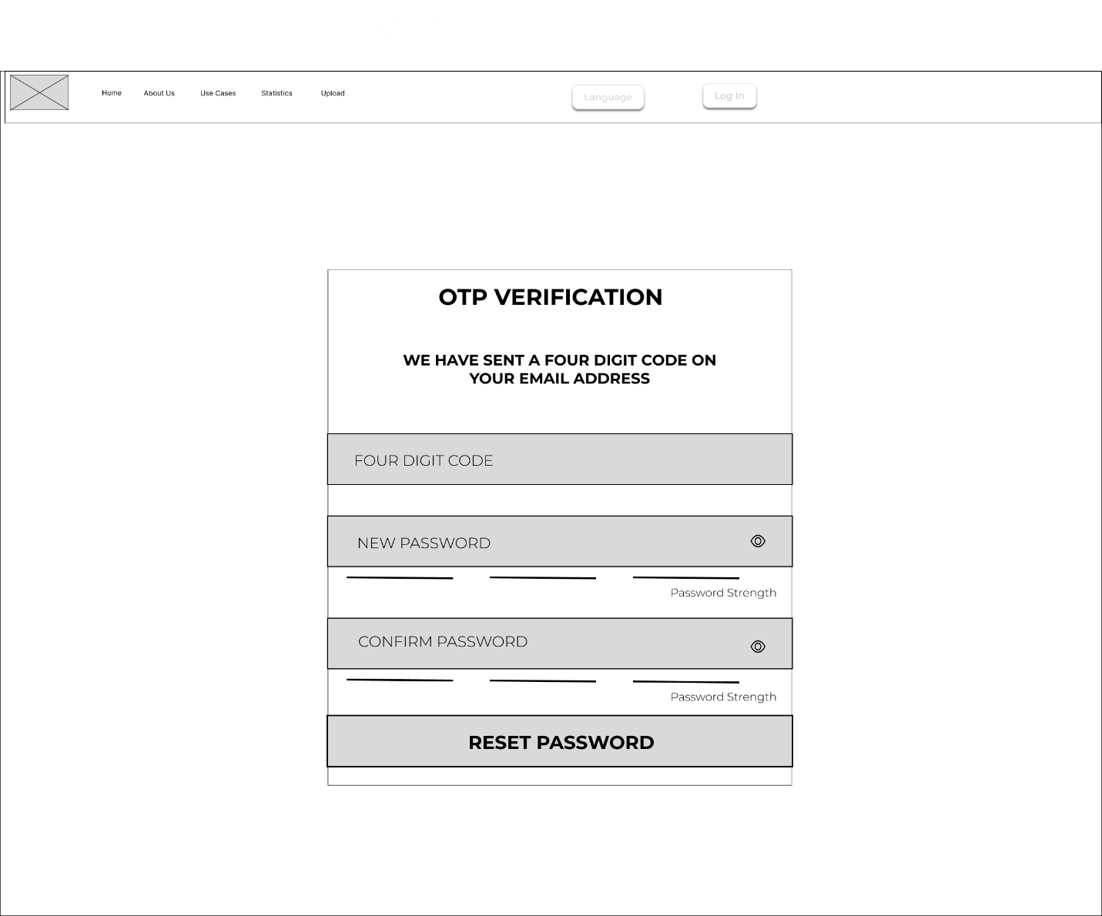

**Wireframe Considerations:**

The Design of the website was designed to balance the functionality of, user experience, and visual appeal, making sure that it meets the need of it diverse audience. Main key considerations which we included:

1. **User Centered Design:** The main goal was to create a seamless user experience by considering the entire user journey, from the homepage to interacting with various pages. The design prioritized ease of use, making sure that the site accessible to user and have right direction of usage.
2. **Visual Hierarchy and Content Prioritization:** To provide a consistent design and to have a visual hierarchy, making sure that the most important information is prominently displayed without any confusion towards user. Providing a clear and simple usage of elements and structure and making sure that user can grasp the information which the page wants to ensure.
3. **Responsive Design:** Multiple usage of devices can used to access the webpage. To provide a ease of use on various platforms, the design need to be responsiveness and also able to interact with the user perfectly across all the designs.
4. **Visual Appealing:** The webpage should appeal to a wide range of users and be designed to deliver the right information with minimal effort. The website page use the minimum elements and colors to provide the right information and appealing good.
5. **Scalability and Future Expansion:** The design also consider the scalability of the website, allowing the future updates or improvements of additional new features. The modular design approach help ensure to provide accessibility or add on to the current website which can seamlessly integrate with current framework without redesigning or not completing with a new design.

**Design:**

**Purpose:**

The Chameleon – MOP Web Design Section is a guide that outlines the structural, functional, and visual aspects of the Chameleon website. This document serves as a detailed resource for designers, developers, and stakeholders, ensuring that every element of the website is meticulously planned and executed to meet the project’s objectives.

This section captures every aspect of the design process, from wireframes and layout considerations to color schemes, typography, and user interactions, laying the foundation for a consistent and engaging user experience.

* **Provide Clarity:** Establish a clear and understanding of the website's design among all project members.
* **Guide Development:** Offer a detailed blueprint for developers, ensuring that the implementation aligns with the design vision.
* **Enhance User Experience:** Focus on creating an intuitive and accessible user interface that need for the website’s audience.

**Typography and Font Usage:**

Typography provides the text component to the Chameleon Website which provides both good visuals to read the webpage and understand the readability of the content. The chosen fonts and their application across different sections of the website ensure a consistent and professional look.

* **Primary Font: Inter**
  + **Usage:** This font is used for all main headings (H1, H2, H3) and key text elements to highlight the main page description.
* **Secondary Font:** **Montserrat**
  + **Usage:** This font is applied to body text, secondary headings, captions, and smaller text elements to complement the primary font.
* **Font Sizes:**
  + H1 (Main Heading): 64px
  + H2 (Subheading): 36px
  + Body Text: 30px , 20px
* **Font Weights:**
* **H1:** Semi Bold
* **Body Text:** Light

**Color Palette and Usage:**

The color scheme is an essential part of the website's visual identity, influencing how users perceive and interact with the content. The following colors are carefully selected to align with the Chameleon brand and enhance the user experience.

* **Primary Color**: #3EB470
  + Usage: Used predominantly for the website’s main elements such as the header, navigation bar, and call-to-action buttons
* **Secondary Color:** #D9D9D9
* Usage: This color is used for background elements and the elements of the image background, table background.
* **Background Color**: #F6F6F6
  + Usage: Used for the page backgrounds and sections, providing a neutral canvas for content.
* **Text Colors**:
* Primary Text Color: #FFFFFF
  + Usage: Applied to the main body text to ensure legibility.
* Secondary Text Color: #000000
  + Usage: Used for paragraphs and information about the page with # 3EB470 background color.
* Link Color: # FFFFFF
  + Usage: To hyperlink the text element which leads to other page.
* **Button Color:**
  + Primary Button Color: # 3EB470
    - Usage: To main call-to-action buttons that need to stand out.
  + Primary Button Text: # FFFFFF
    - Usage: Text color that contrasts with the button background.
  + Secondary Button Color: # FFFFFF
    - Usage: To have non prominent button such login or signup
  + Secondary Text Color: # 3EB470
    - Usage: To have the text on the second prominent button.

**Icons and Imagery**

Icons and images play a crucial role in enhancing the visual appeal and usability of the website. They provide visual cues that can help users navigate the site more efficiently.

* **Icon Style**: Outline
  + **Usage**: Icons are used across the site to represent actions, categories, and features visually.
  + **Purpose**: The icon style should be consistent throughout the website, complementing the overall design aesthetic.

Below company Logos are used in Chameleon webpages.

**Website Logo:**

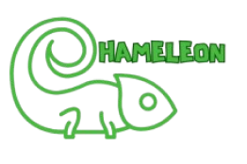

Below Images are used in the development of website.

**Homepage:**

1. Main Image

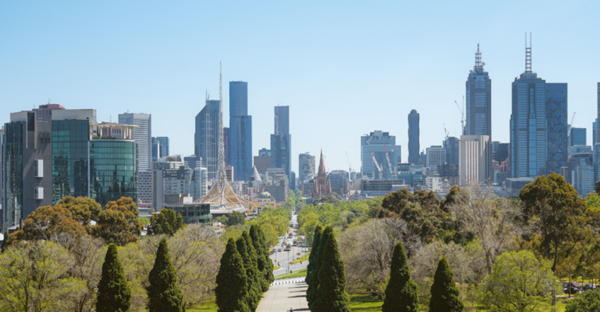

1. Our Vision image

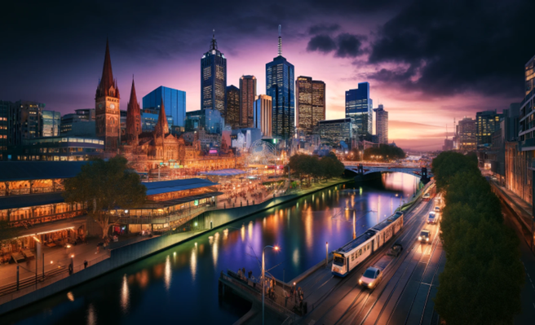

1. Case study image



**About Us page:**

1. Main About Us Image

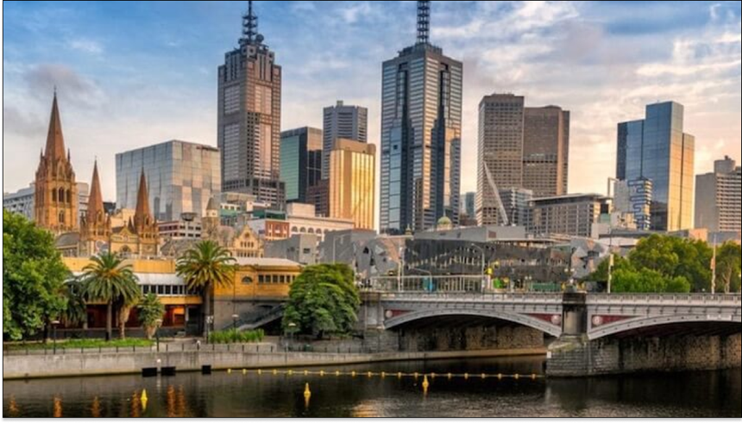

1. Open data leadership card



1. Our Goals Card



**Contact Us Page:**

1. Contact Us

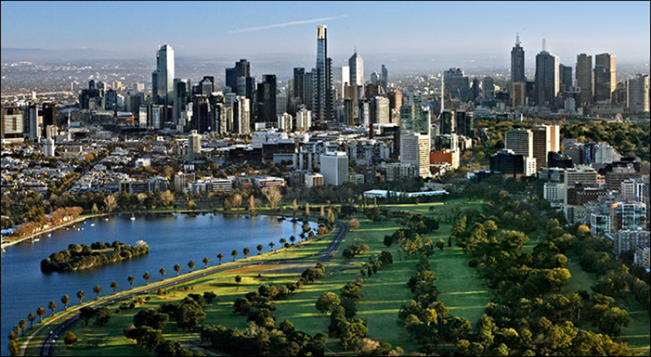

**Buttons and Interactive Elements**

Buttons and interactive elements are designed to be intuitive and responsive, providing users with clear and immediate feedback during their interaction with the website.

* **Button Styles**:
  + **Primary Button**: Curved Corners

**Usage**: Used for critical actions like Sign up and login.

1. Login



1. Sign Up



1. Language



1. Search



* + **Secondary Button**: Sharp Corner

**Usage**: These buttons are used for key actions like “Submit,” or “Learn More.”



**Grid System and Layout**

A well-defined grid system is essential for creating a structured and balanced layout that guides the user through the content logically.

* **Grid System:** 9 – Grid point
* Usage**:** The grid system provides to showcase the similar items on a single page.
* Purpose**:** It helps maintain consistency in spacing, alignment, and layout, providing a visually cohesive experience.

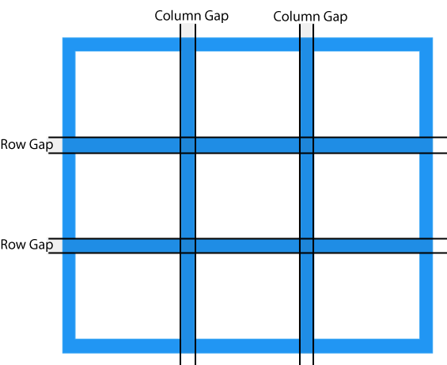

* **Layout Guidelines:**
* Margin: 108px between boxes.
* Usage: Ensures there is adequate space between different sections and elements, enhancing readability and visual flow.

**Web Design Templates**

The below are design template done by the design team for each page based on the structure of wireframes and implemented to maintain consistent with the wireframe design and followed the consistent mentioned font size and color for the design template.

Each design represents the web design of the webpage.

**Home Page:**

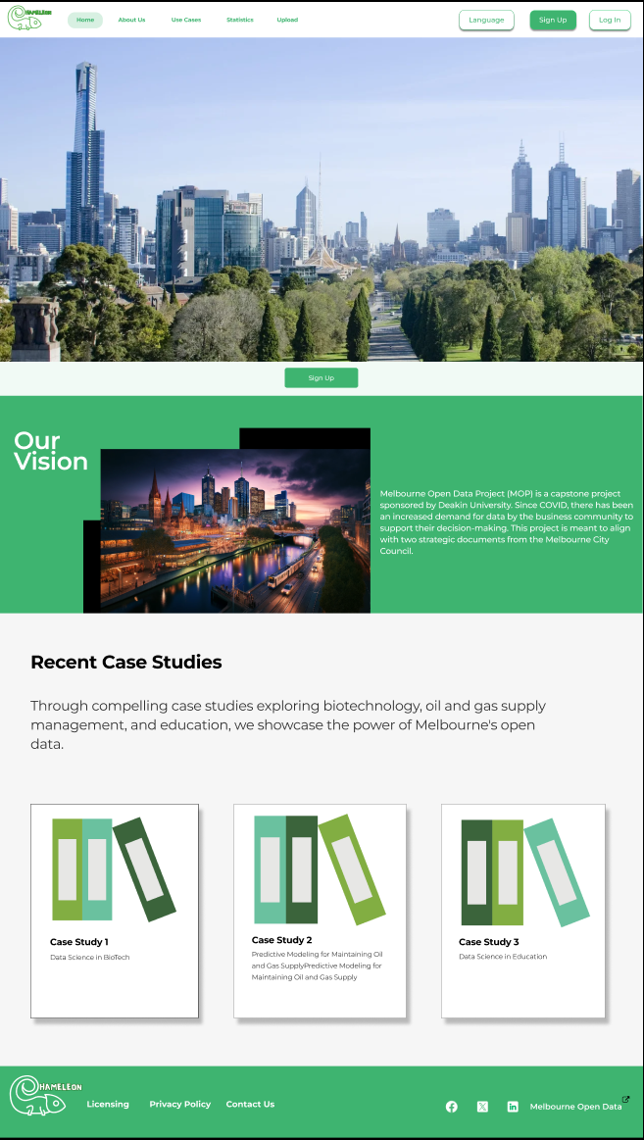

**Font Details:**

**Our Vision**

* Font Type: Montserrat
* Color: White (#FFFFFF)
* Heading Size: 64px/Bold
* Description Size: 22px/Medium

**Recent Case Studies**

* Font Type: Montserrat
* Color: Black (#000000)
* Heading Size: 48px/Bold
* Description Size: 36px/Regular

Dark Theme:

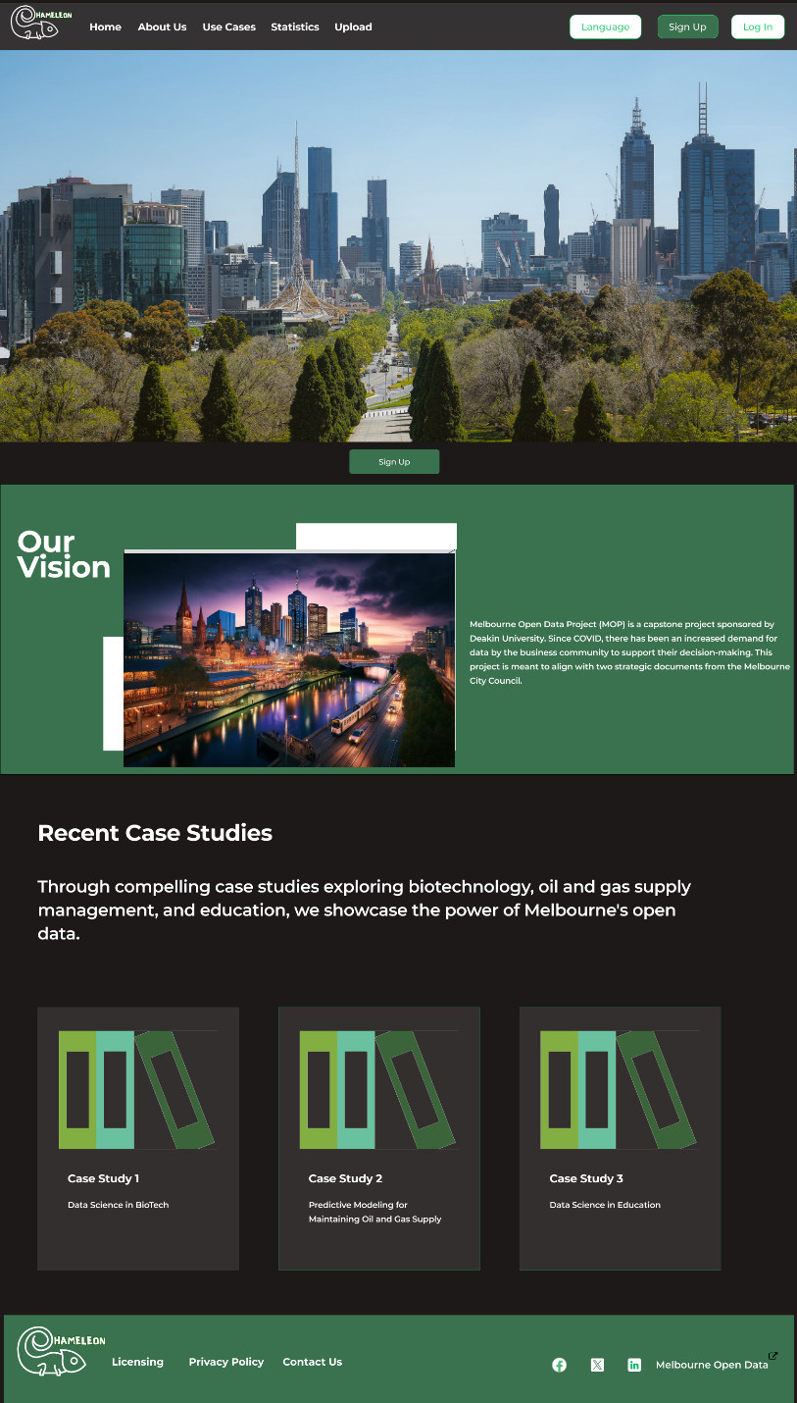

**Theme Details:**

**Our Vision**

* Background colour: #3A714E
* Font Type: Montserrat
* Font Color: White (#FFFFFF)
* Heading Size: 64px/Bold
* Description Size: 22px/Medium(#FFFFFF)

**Recent Case Studies**

* Background colour: #1D1919
* Font Type: Montserrat
* Font-Color: White(# FFFFFF)
* Heading Size: 48px/Bold
* Description Size: 36px/Regular

**Mobile View:**

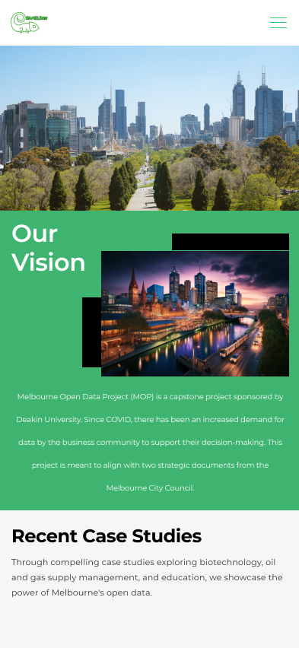 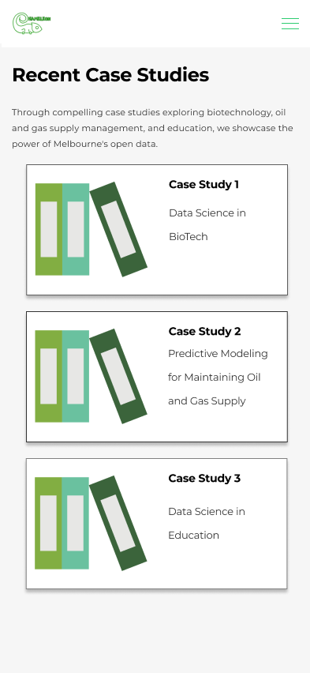

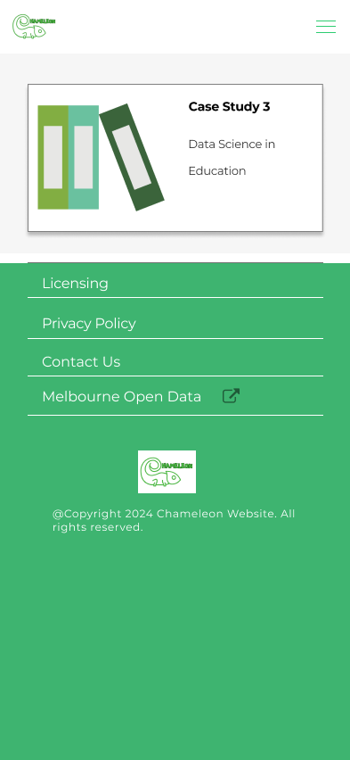

**Font Details:**

**Our Vision**

* Font Type: Montserrat
* Color: White (#FFFFFF)
* Heading Size: 32px/SemiBold
* Description Size: 10px/Medium

**Recent Case Studies**

* Font Type: Montserrat
* Color: Black (#000000)
* Heading Size: 24px/Bold
* Description Size: 11px/Regular

**About Us page:**

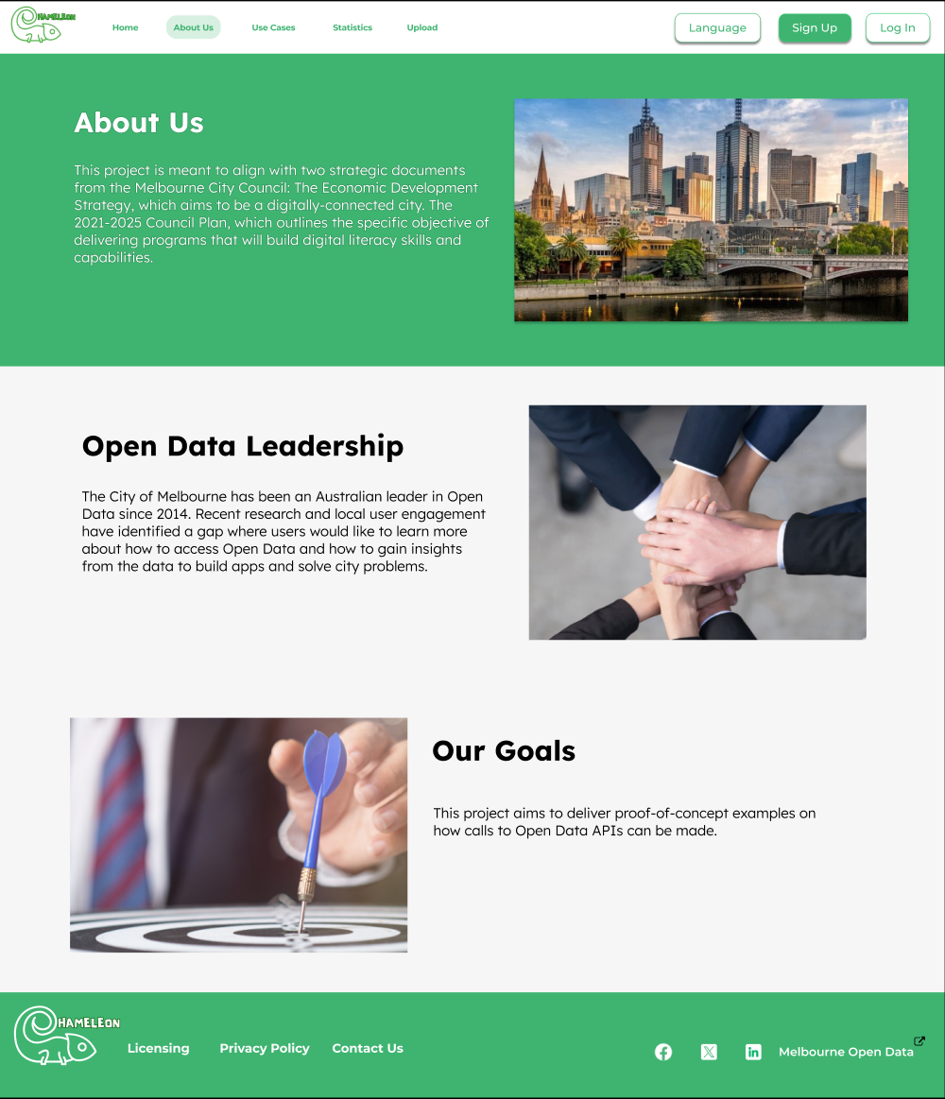

**Font Details:**

**About Us**

* Font Type: Lexend Deca
* Color: White (#FFFFFF)
* Heading Size: 50px/Bold
* Description Size: 25px/Light

**Open Data Leadership/Our Goals**

* Font Type: Lexend Deca
* Color: Black (#000000)
* Heading Size: 50px/Bold
* Description Size: 25px/Light

**Dark Mode:**

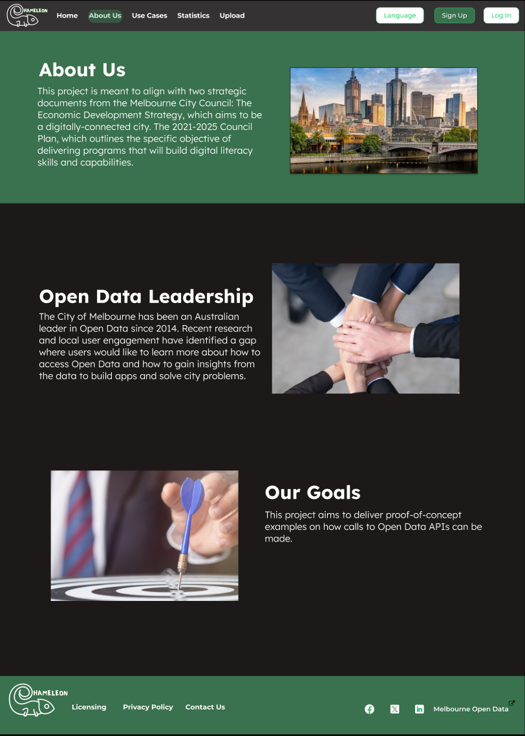

**Font Details:**

**About Us**

* Font Type: Lexend Deca
* Color: White (#FFFFFF)
* Heading Size: 50px/Bold
* Description Size: 25px/Light

**Open Data Leadership/Our Goals**

* Font Type: Lexend Deca
* Color: White (#FFFFFF)
* Heading Size: 50px/Bold
* Description Size: 25px/Light

**Mobile Mode:**

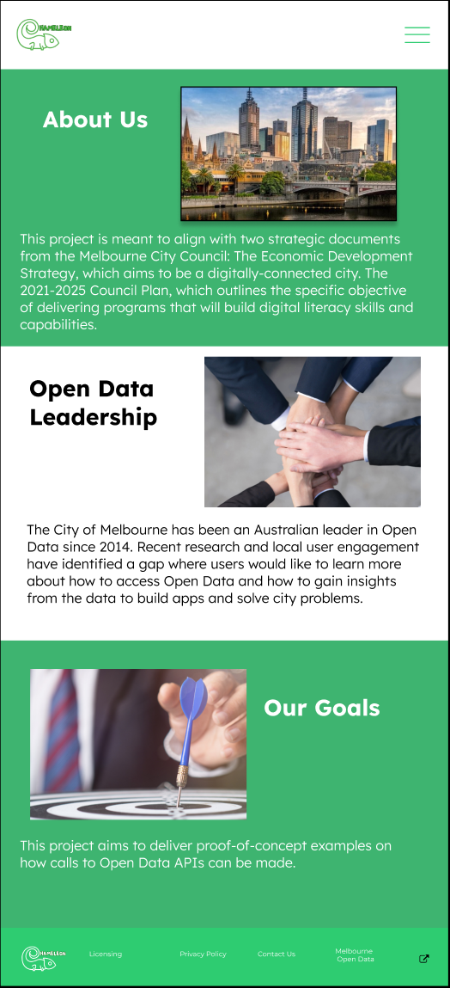

**Font Details:**

**About Us/ Our Goals**

* Font Type: Lexend Deca
* Color: White (#FFFFFF)
* Heading Size: 20px/Bold
* Description Size: 12px/Light

**Open Data Leadership/Our Goals**

* Font Type: Lexend Deca
* Color: Black(#000000)
* Heading Size: 20px/Bold
* Description Size: 12px/Light

**Use Cases Page:**

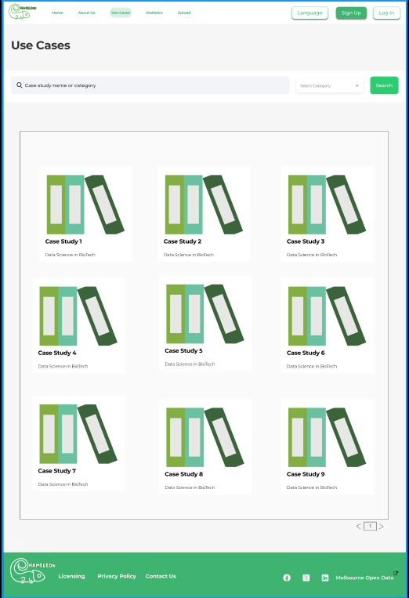

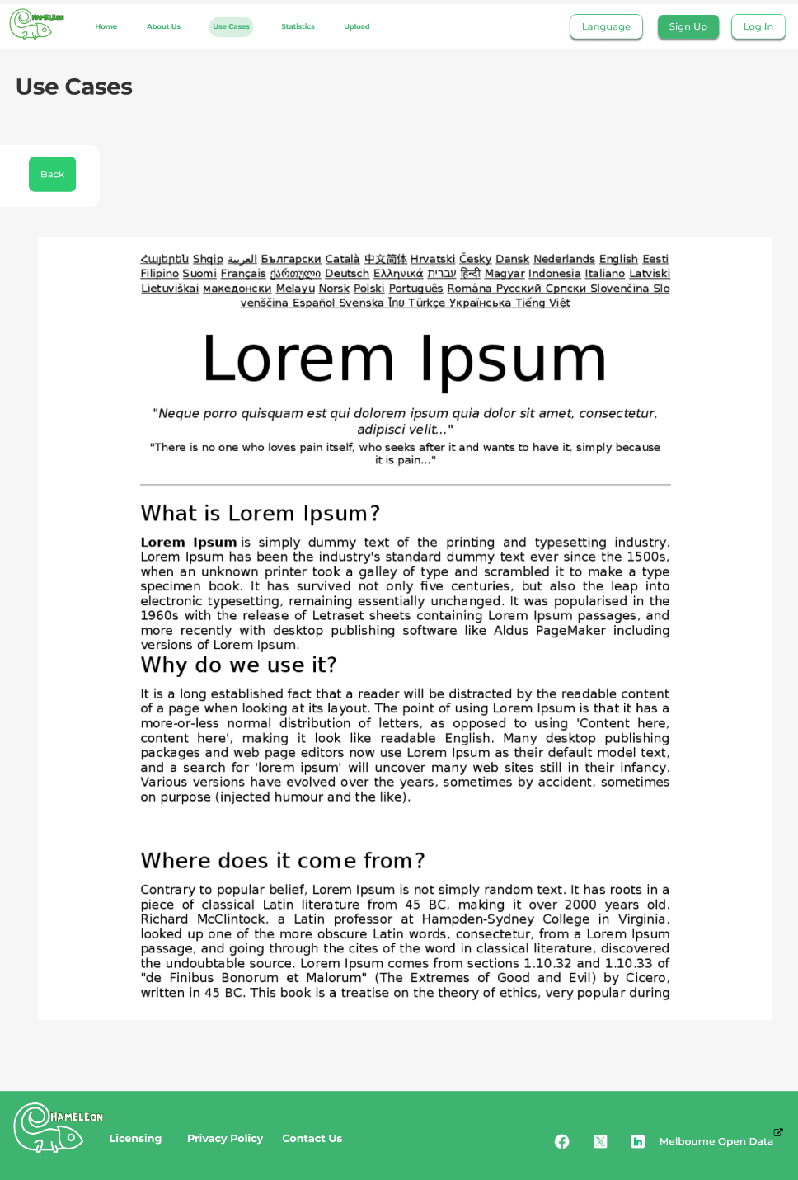

**Font Details:**

**Case Study**

* Font Type: Monserrat
* Color: Black(#000000)
* Heading Size: 24px/Bold
* Description Size: 18px/Regular
* case study cards (case study 1, case study 2.....) - 24 Bold/Montserrat
* case study names - 18 regular/Montserrat

**Dark Theme:**

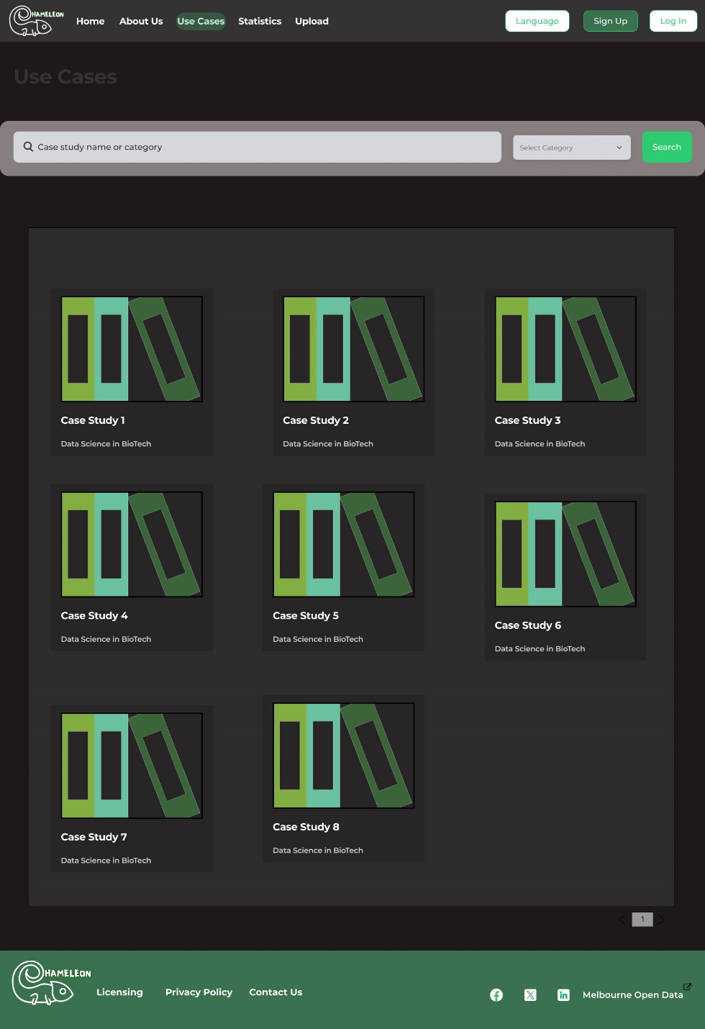

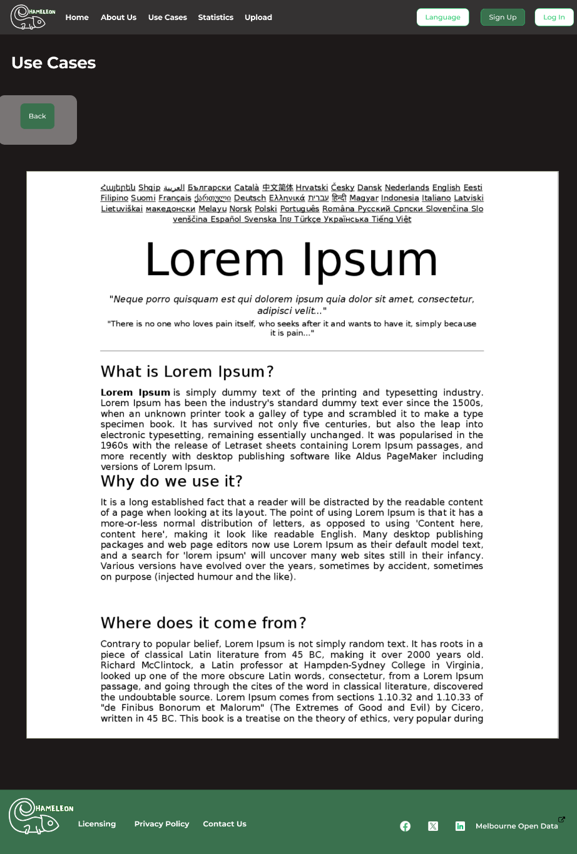

**Font Details:**

**Case Study**

* Page Background colour: #1D1919
* Case studies background colour: #2E2D2D
* Cards background colour: #272525
* Font Type: Monserrat
* Color: White (#FFFFFFF)
* Heading Size: 24px/Bold
* Description Size: 18px/Regular
* case study cards (case study 1, case study 2.....) - 24 Bold/Montserrat
* case study names - 18 semi-bold/Montserrat

**Mobile View:**

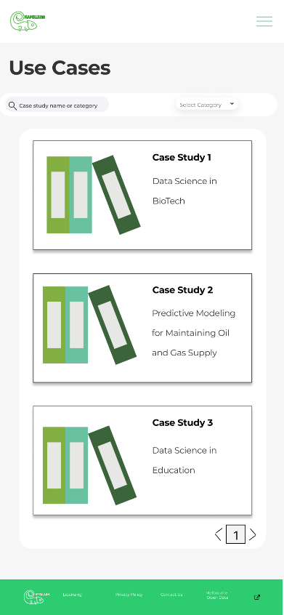

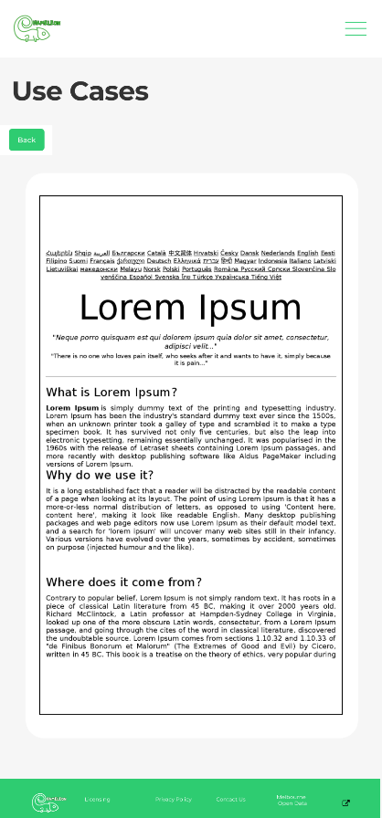

Font Details:

**Case Study**

* Page Background colour: #1D1919
* Case studies background colour: #2E2D2D
* Cards background colour: #272525
* Font Type: Monserrat
* Color: White (#FFFFFFF)
* Heading Size: 18px/Bold
* Description Size: 8px/Regular
* case study cards (case study 1, case study 2.....) - 24 Bold/Montserrat
* case study names – 10 semi-bold/Montserrat

**Statistic Page**

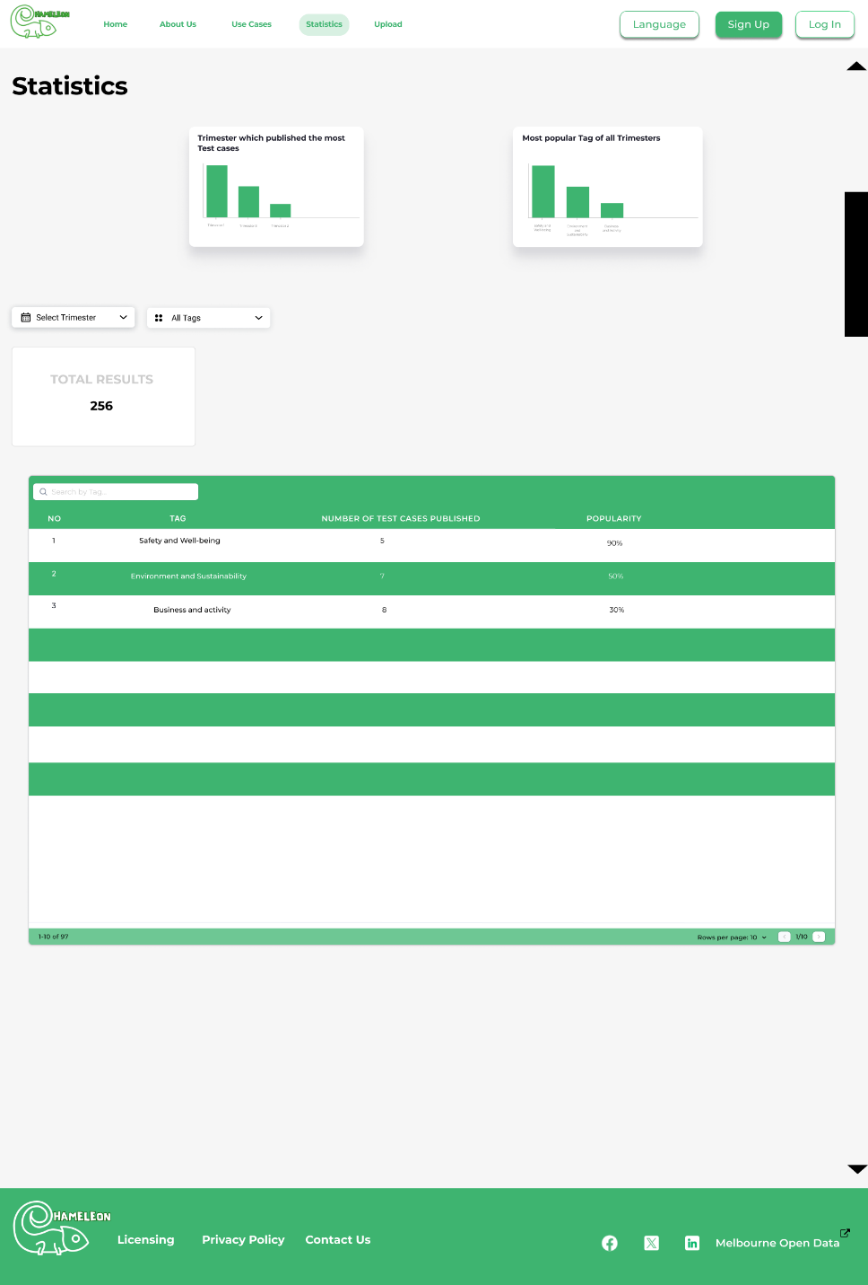

**Font details**

* Bar Graphs:

Main Heading

* Type: Montserrat
* Size: 15px/Bold
* Colour: #171725

Bar representation

* Type: Montserrat
* Size: 6px/Regular
* Colour: #747474
* Select trimester/All tags Dropdown
* Type: Roboto
* Size: 16px/Regular
* Colour: #000000
* Total Results
* Type: Montserrat
* Size: 24px/Bold
* Colour: #CCCCCC
* Total results number
* Type: Montserrat
* Size: 24px/Bold
* Colour: #000000
* Table:
* 1st colour: #3EB470
* Font colour: #FFFFFF
* 2nd colour: #FFFFFF
* Font colour: #000000
* Type: Montserrat
* Size: 24px/Bold (for column headings)
* Size: 14px/Medium (for rows data)
* Page Font Type: Montserrat
* Page Font colour: 000000
* Page Font Size: 12px/Medium

**Dark Theme:**

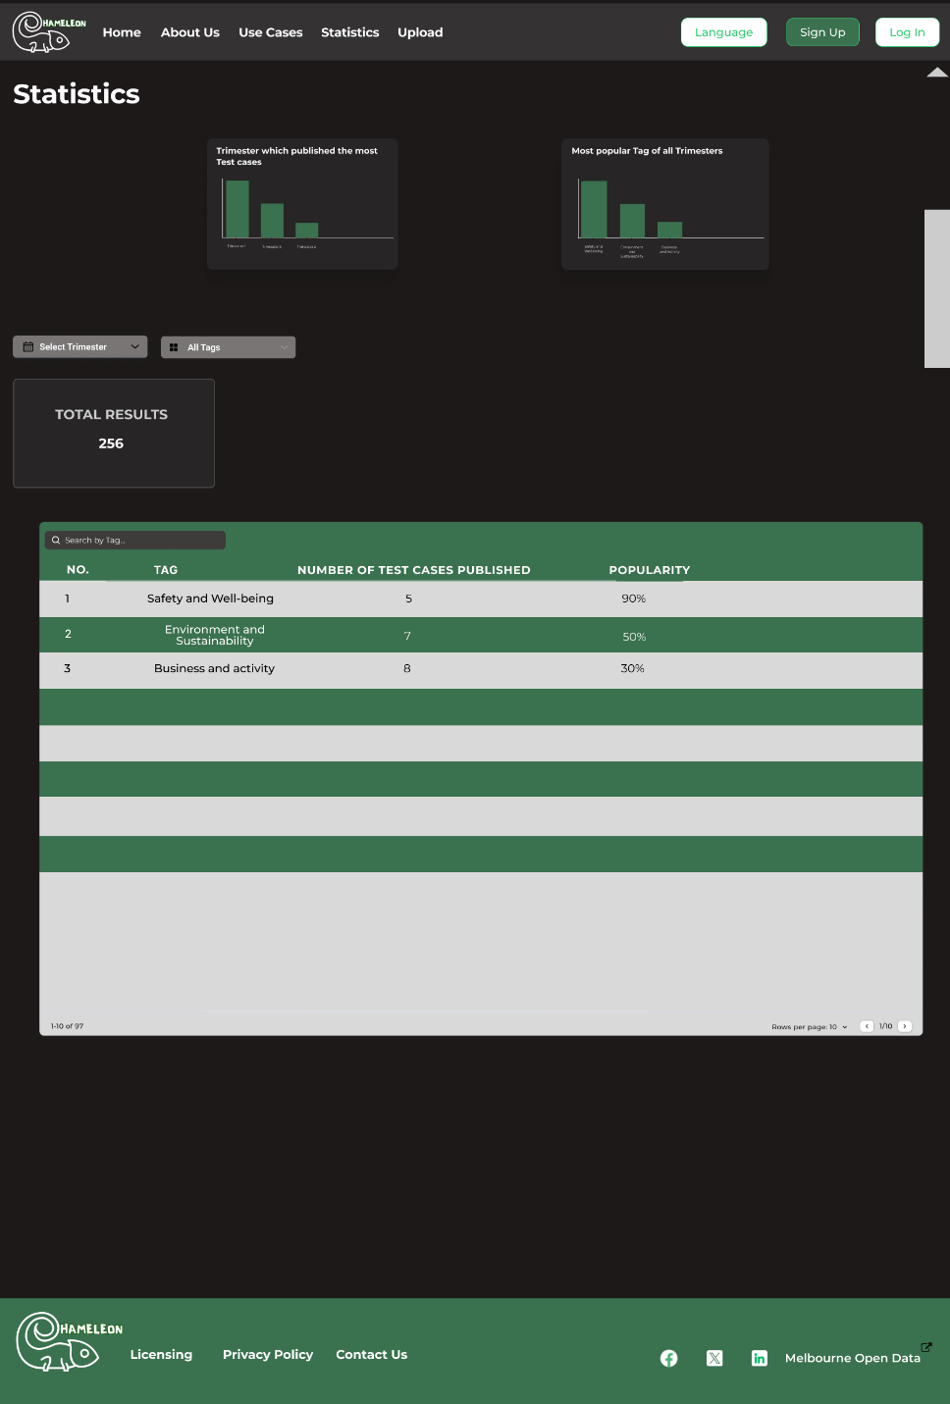

**Details**

* Bar Graphs:

Main Heading

* + Background- Colour: #272525
* Type: Montserrat
* Size: 15px/Bold
* Font Colour: # FFFFFF

Bar representation

* Type: Montserrat
* Bar-colour: #3A714E
* Size: 6px/Regular
* Colour: #FFFFFF
* Select trimester/All tags Dropdown
* Type: Roboto
* Size: 16px/Regular
* Colour: #797575
* Font colour: #FFFFFF
* Total Results
* Box-colour: #272525
* Type: Montserrat
* Size: 24px/Bold
* Font-Colour: #CCCCCC
* Total results number
* Type: Montserrat
* Size: 24px/Bold
* Colour: #FFFFFF
* Table:
* 1st colour: #3A714E
* Font colour: #FFFFFF
* 2nd colour: # D9D9D9
* Font colour: #000000
* Type: Montserrat
* Size: 24px/Bold (for column headings)
* Size: 14px/Medium (for rows data)
* Page Font Type: Montserrat
* Page Font colour: #000000
* Page Font Size: 12px/Medium

**Mobile view:**

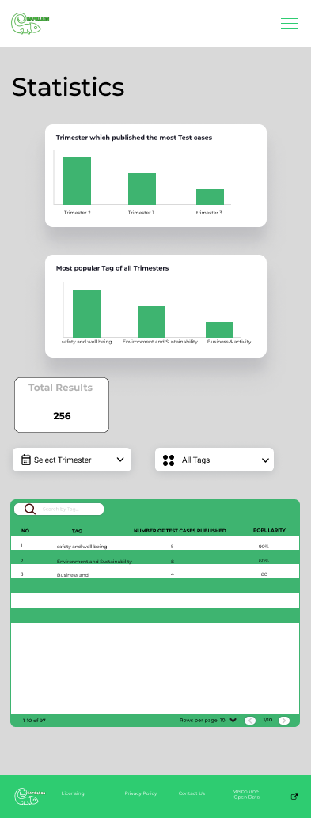

**Details**

* Bar Graphs:

Main Heading

* + Background- Colour: #D9D9D9
* Type: Montserrat
* Size: 8px/Bold
* Font Colour: # FFFFFF

Bar representation

* Type: Montserrat
* Bar-colour: #3A714E
* Size: 6px/Regular
* Colour: #FFFFFF
* Select trimester/All tags Dropdown
* Type: Roboto
* Size: 10px/Regular
* Colour: #797575
* Font colour: #FFFFFF
* Total Results
* Box-colour: #272525
* Type: Montserrat
* Size: 12px/Bold
* Font-Colour: #CCCCCC
* Total results number
* Type: Montserrat
* Size: 12px/Bold
* Colour: #FFFFFF
* Table:
* 1st colour: #3A714E
* Font colour: #FFFFFF
* 2nd colour: # D9D9D9
* Font colour: #000000
* Type: Montserrat
* Size: 6px/Bold (for column headings)
* Size: 6px/Medium (for rows data)
* Page Font Type: Montserrat
* Page Font colour: #000000
* Page Font Size: 6px/Medium

**Upload Case Study Page:**

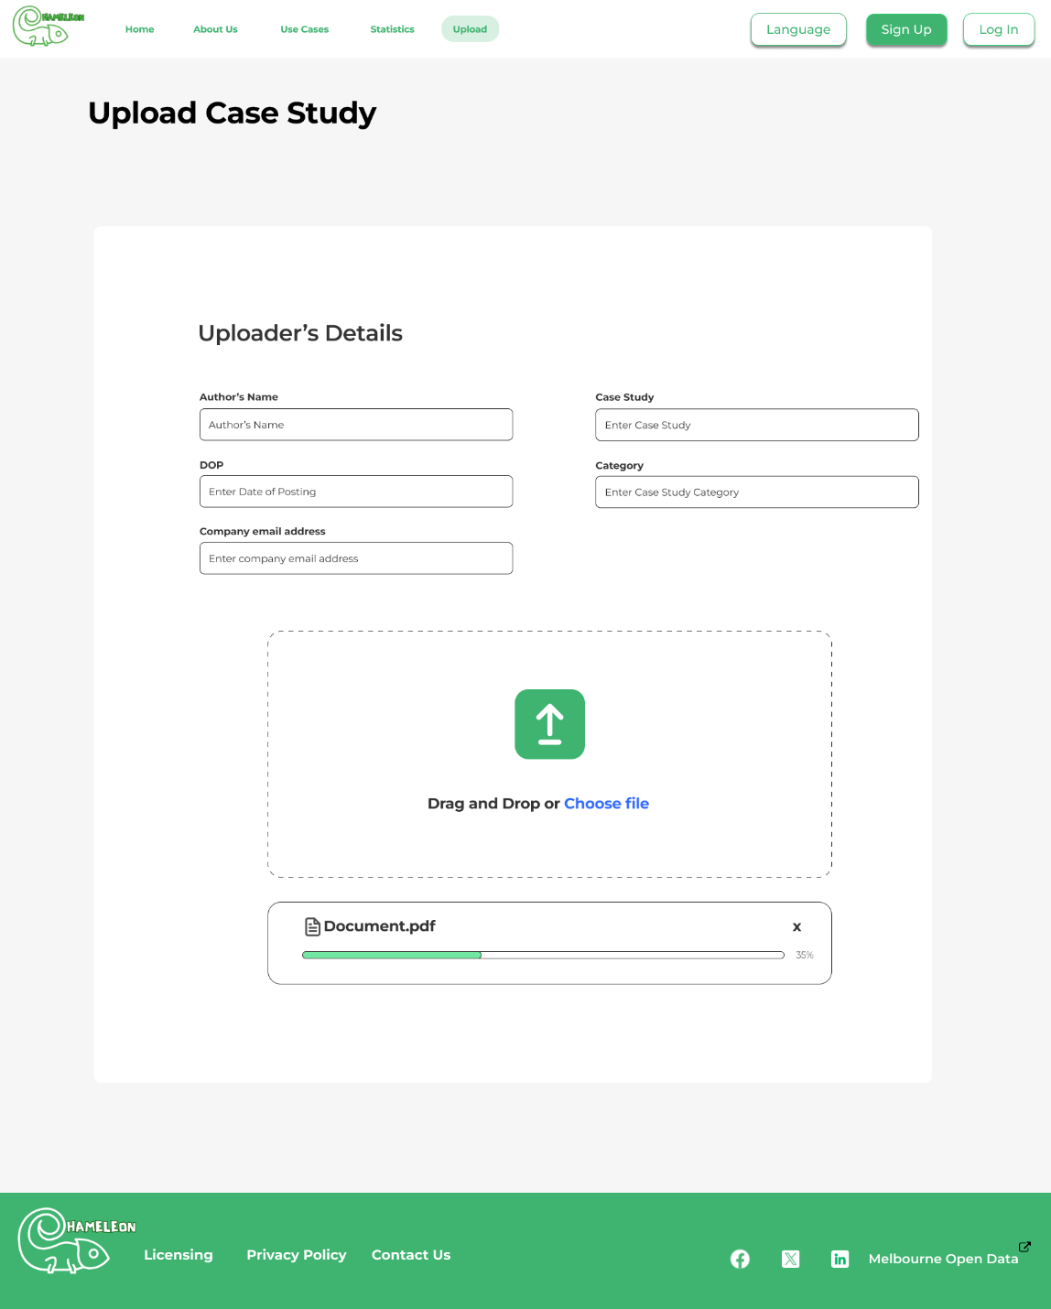

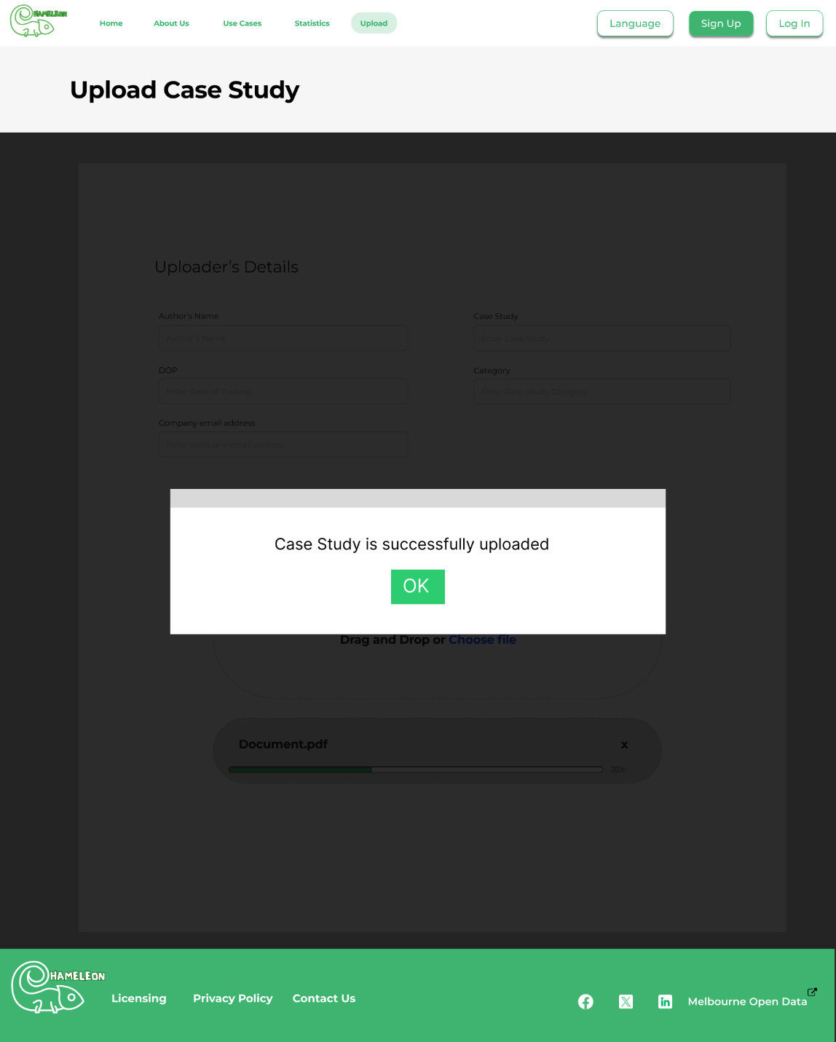

**Font Details:**

Heading

* Font Type: Montserrat
* Size: 48px/Bold
* Colour: #000000

**Details Section:**

* **Text box names:**
* Font Type: Montserrat
* Size: 16px/Bold
* Colour: #000000
* Labels:
* Font Type: Montserrat
* Size: 16px/Regular
* Colour: #000000

**Dark Theme:**

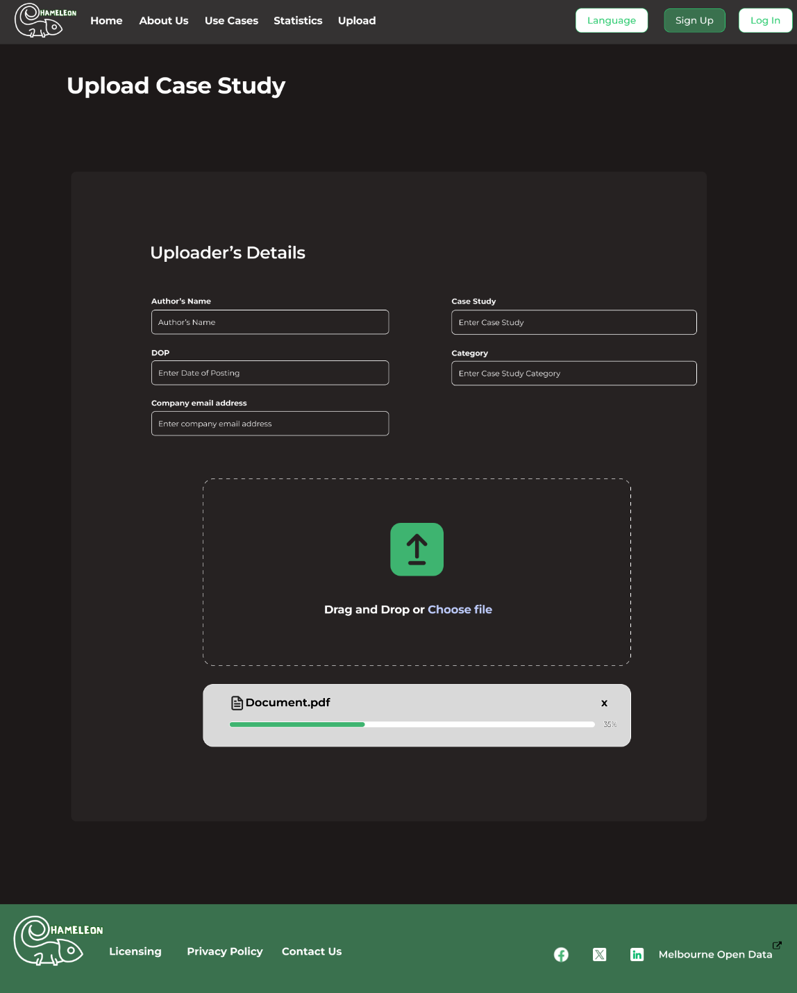

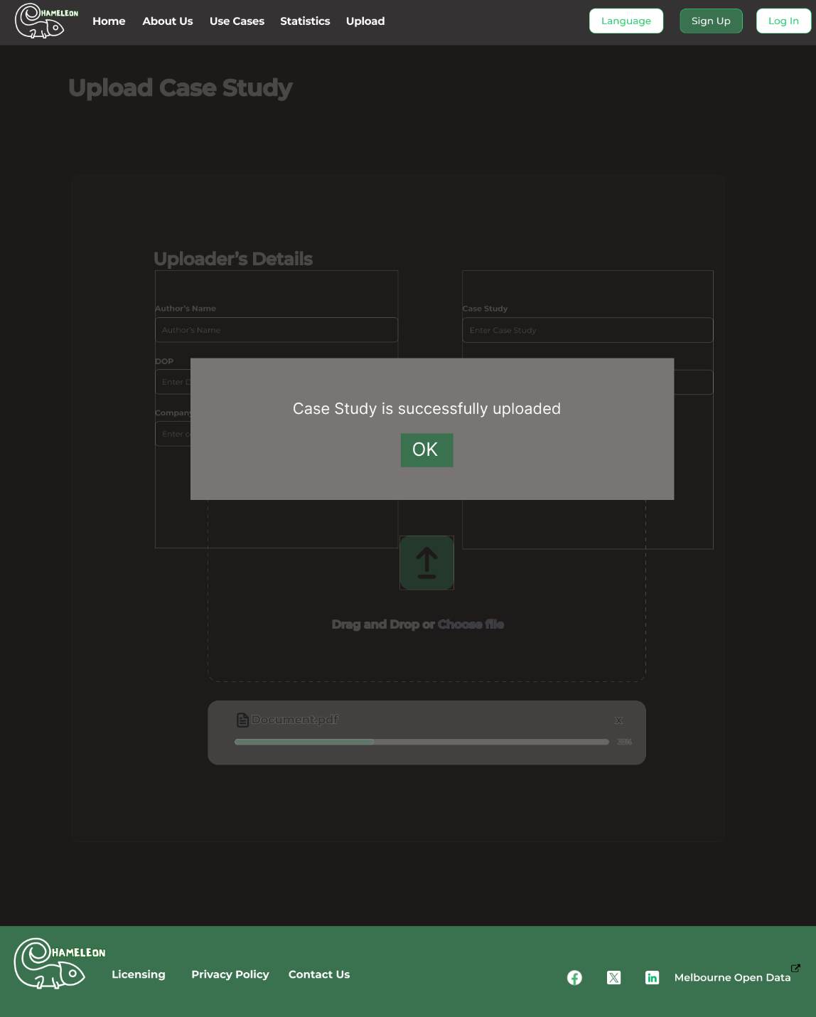

**Details:**

Webpage background colour: #1D1919

**Heading**

* Font Type: Montserrat
* Size: 48px/Bold
* Colour: #FFFFFF

**Details Section:**

Background colour: #2E2D2D

* **Text box names:**
* Font Type: Montserrat
* Size: 16px/Bold
* Colour: # FFFFFF
* Labels:
* Font Type: Montserrat
* Size: 16px/Regular
* Colour: # FFFFFF

**Contact Us Page:**

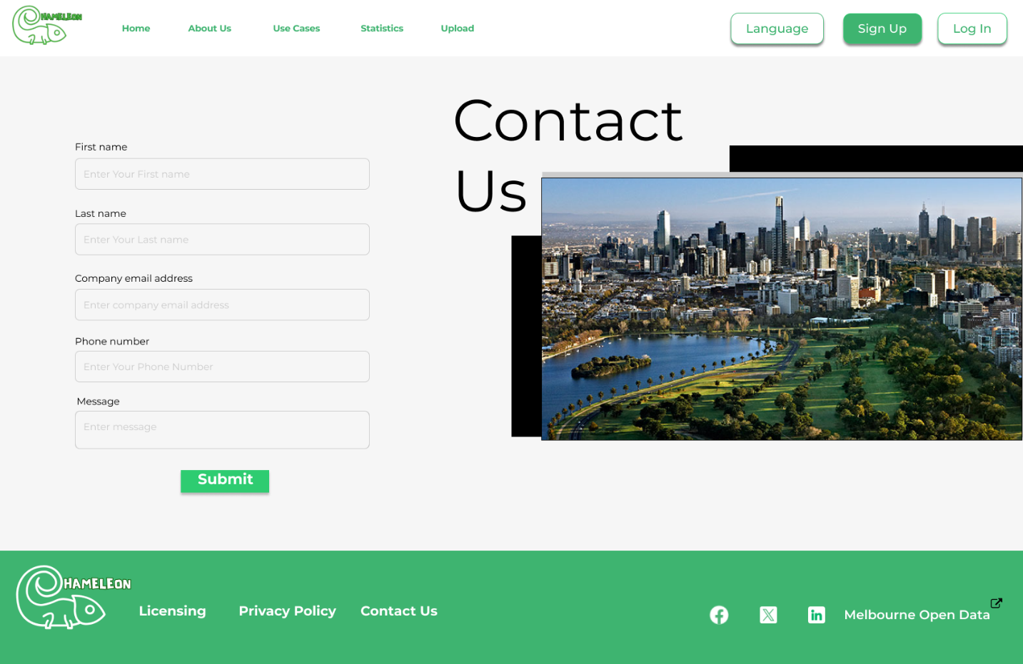

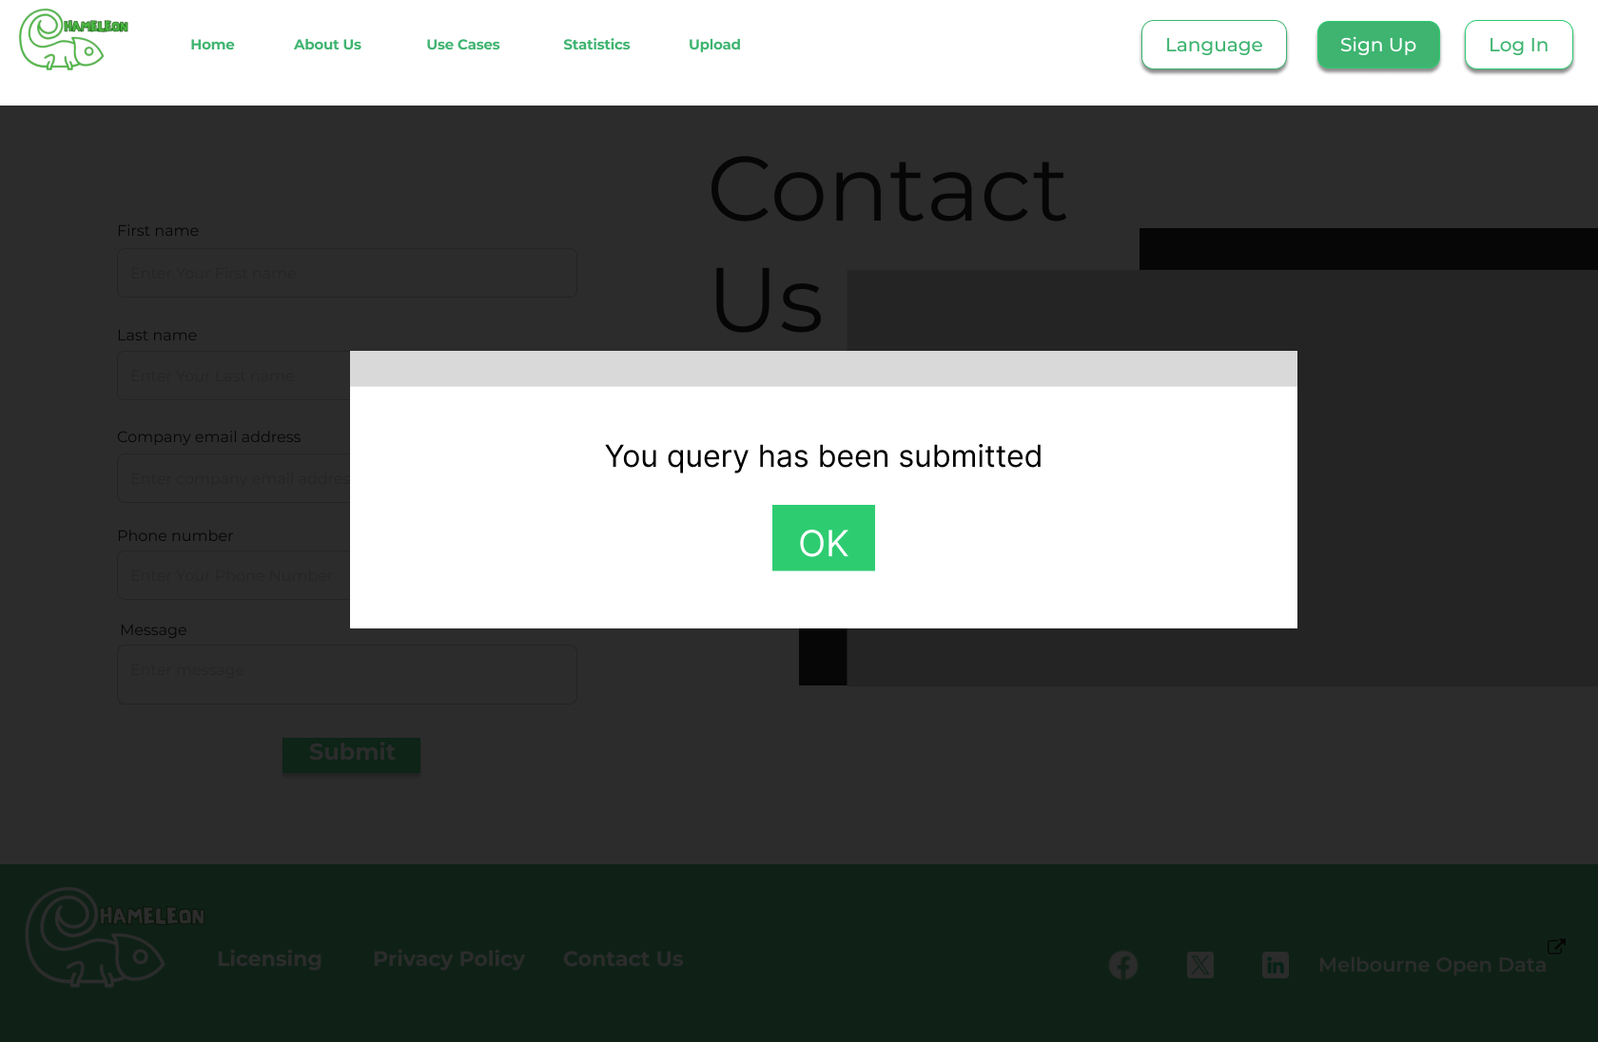

Font Details:

* Contact Us Main Heading
* Type: Montserrat
* Colour: #000000
* Size: 96px/Regular
* Textbox Header
* Type: Montserrat
* Colour: #000000
* Size: 16px/Regular
* Textbox label
* Type: Montserrat
* Colour: #CCCCCC
* Size: 16px/Regular
* Submitted window
* Type: Inter
* Colour: # 020202
* Size: 32px/Regular

**Dark Theme:**

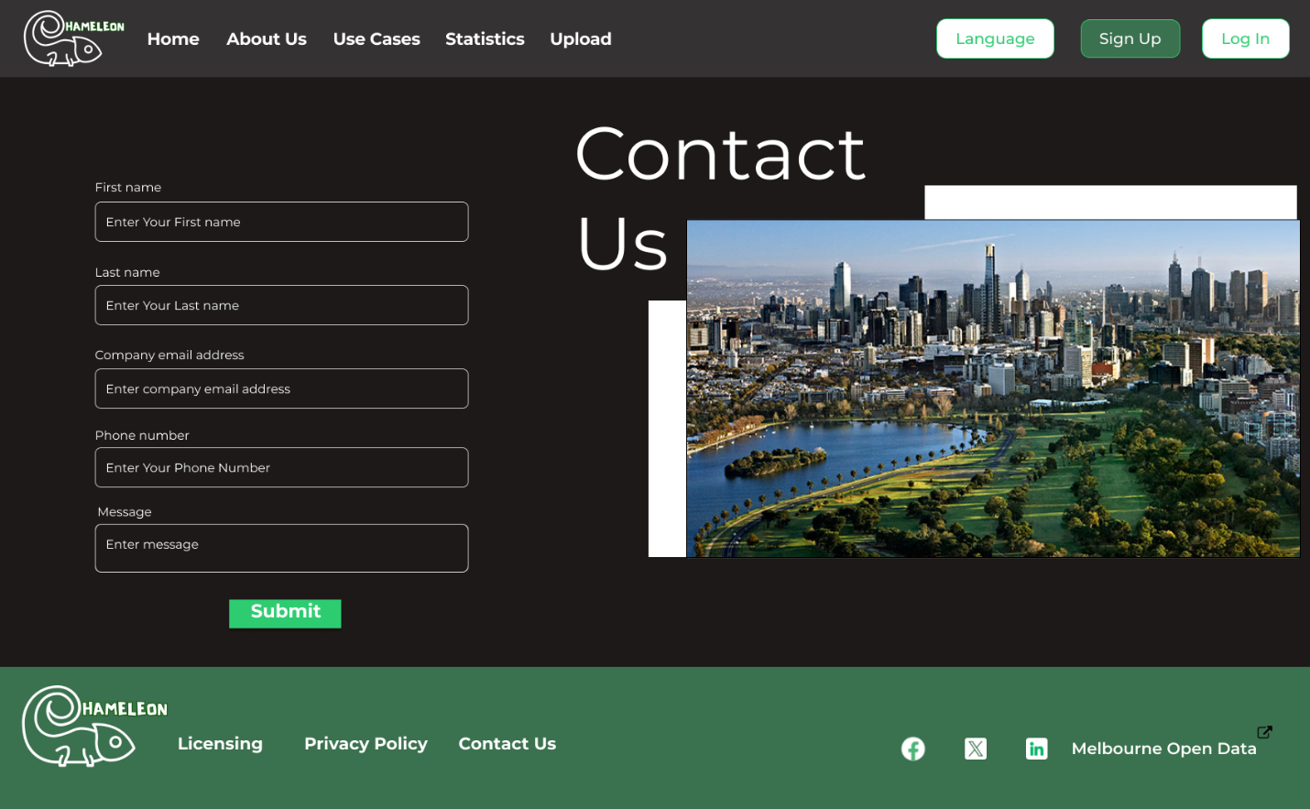

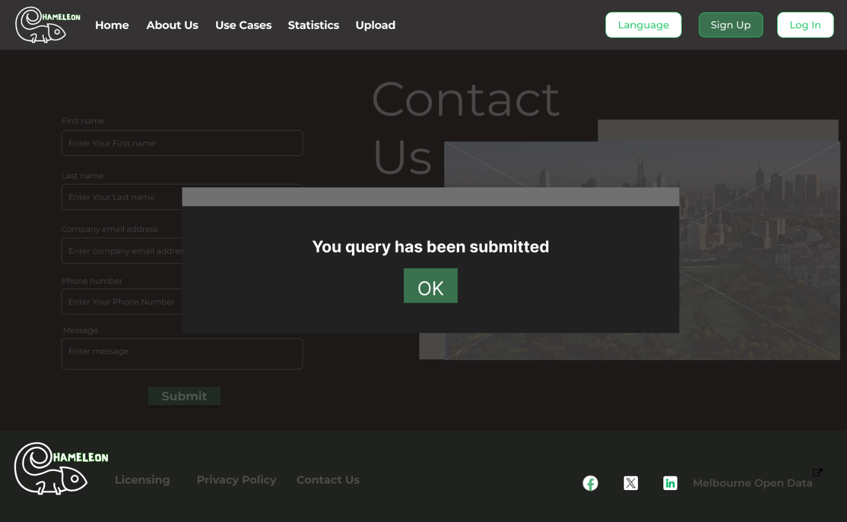

**Details**:

Webpage background colour: #1D1919

* Contact Us Main Heading
* Type: Montserrat
* Colour: # FFFFFF
* Size: 96px/Regular
* Textbox Header
* Type: Montserrat
* Colour: # FFFFFF
* Size: 16px/Regular
* Textbox label
* Type: Montserrat
* Colour: # FFFFFF
* Size: 16px/Regular
* Submitted window
* Type: Inter
* Colour: # 020202
* Size: 32px/Regular
* Submit/Ok button colour: #3A714E

**Mobile View:**

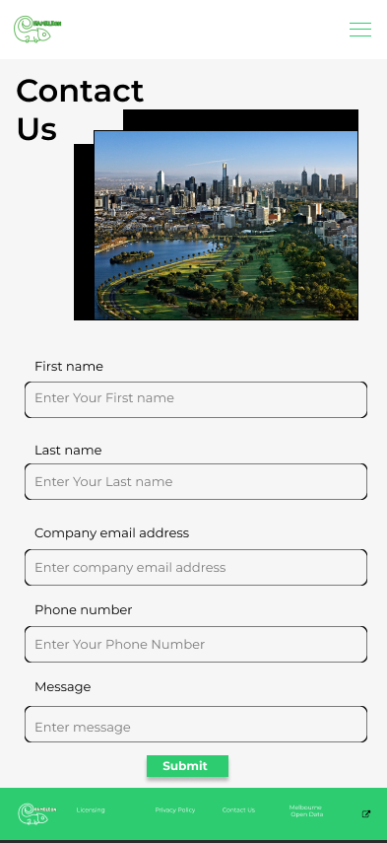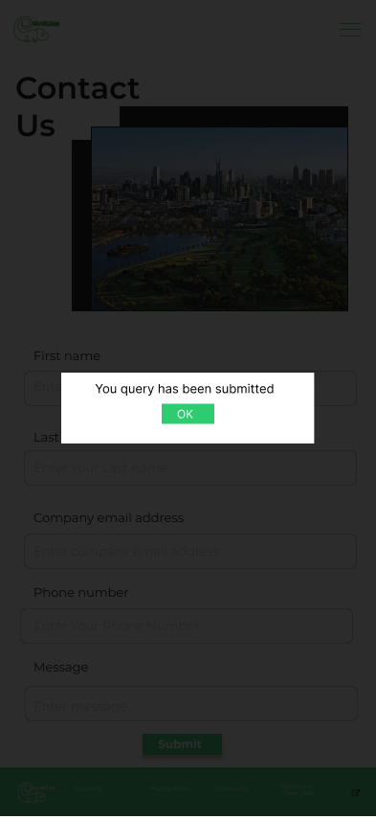

Font Details:

* Contact Us Main Heading
* Type: Montserrat
* Colour: #000000
* Size: 32px/SemiBold
* Textbox Header
* Type: Montserrat
* Colour: #000000
* Size: 13px/Regular
* Textbox label
* Type: Montserrat
* Colour: # F6F6F6
* Size: 13px/Regular
* Submitted window
* Type: Inter
* Colour: # 020202
* Size: 13px/Regular
* Transparent screen : # 070707

**Licensing Page:**

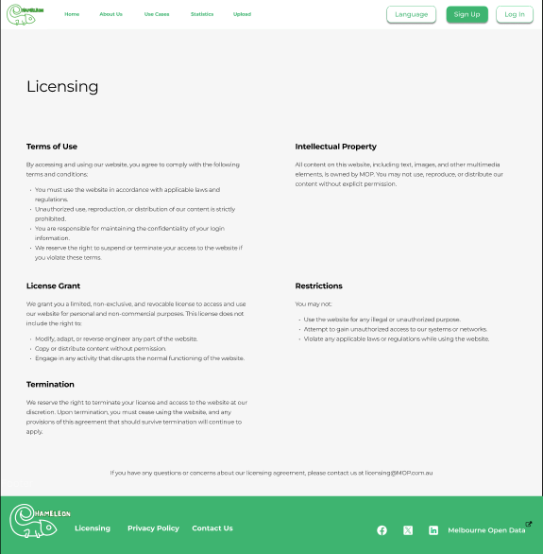

**Font Details:**

**Licensing**

* Font Type: Monserrat
* Color: White (#000000)
* Heading Size: 48px/Regular

**Licensing Information**

* Font Type: Monserrat
* Color: White (#000000)
* Heading Size: 24px/Bold
* Description Size: 18px/Regular

**Dark Theme:**

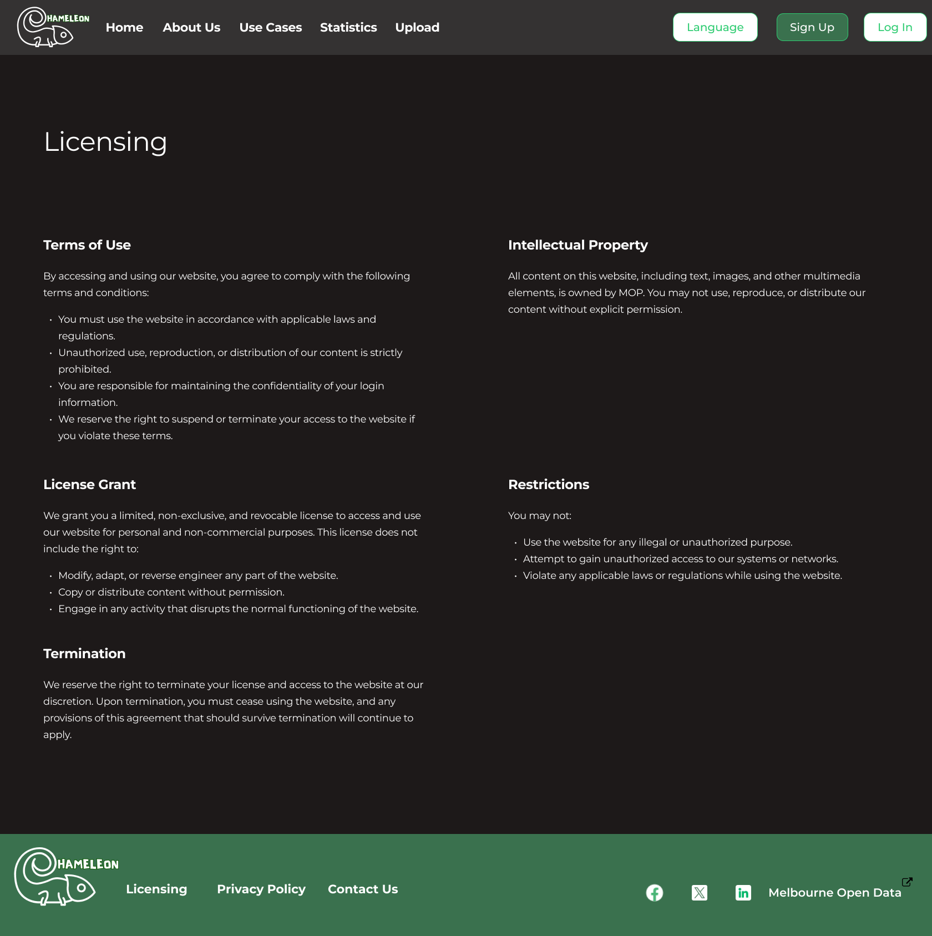

**Details:**

Background colour: #1D1919

**Licensing**

* + Font Type: Monserrat
  + Color: White (# FFFFFF)
  + Heading Size: 48px/Regular

**Licensing Information**

* + Font Type: Monserrat
  + Color: White (# FFFFFF)
  + Heading Size: 24px/Bold
  + Description Size: 18px/Regular

**Mobile view**

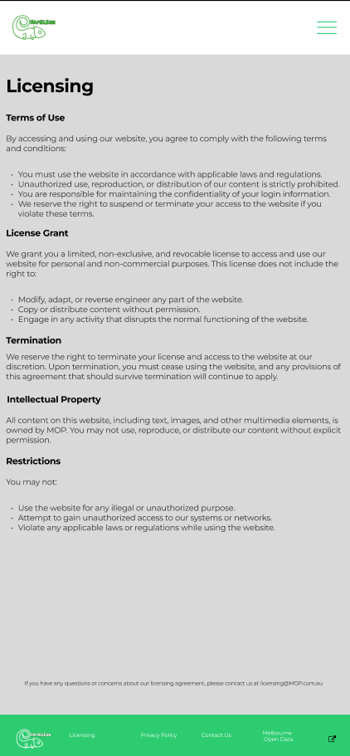

Font Details:

* **Licensing Main Heading**
* Type: Montserrat
* Colour: #000000
* Size: 20px/Bold
* **Subheadings**
* Type: Montserrat
* Colour: #000000
* Size: 10px/Bold
* **Descriptions**
* Type: Montserrat
* Colour: #000000
* Size: 9px/Regular

**Privacy Page.**

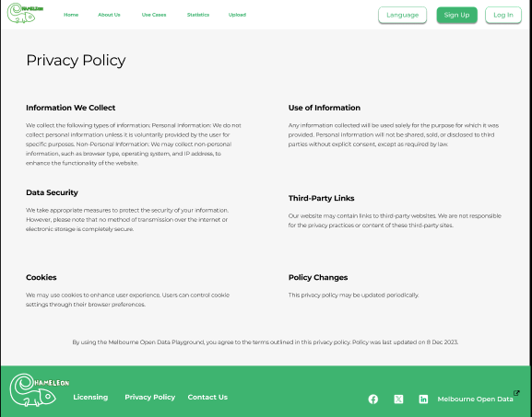

**Details:**

**Privacy Policy**

* Font Type: Monserrat
* Color: White (#000000)
* Heading Size: 48px/Regular

**Privacy Policy Information**

* Font Type: Monserrat
* Color: White (#000000)
* Heading Size: 24px/Bold
* Description Size: 18px/Regular

Dark Theme

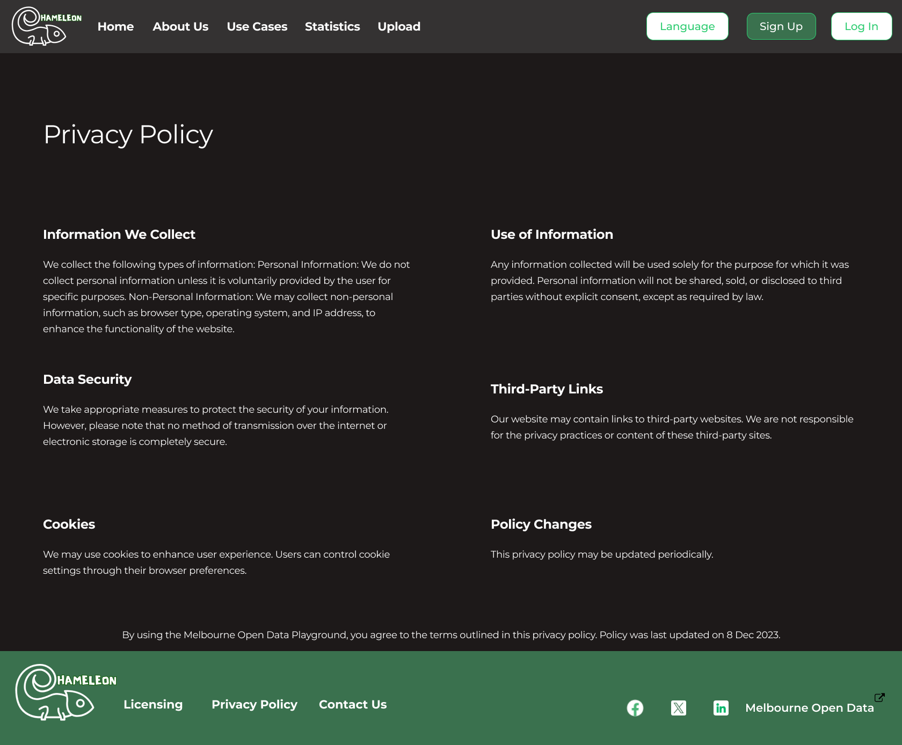

**Details:**

Background colour: #1D1919

**Privacy Policy**

* Font Type: Monserrat
* Color: #FFFFFF
* Heading Size: 48px/Regular

**Privacy Policy Information**

* Font Type: Monserrat
* Color: #FFFFFF
* Heading Size: 24px/Bold
* Description Size: 18px/Regular

Mobile view:

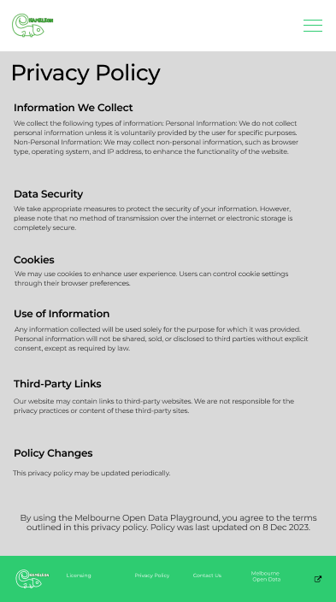

**Details:**

Background colour: #D9D9D9

**Privacy Policy**

* Font Type: Monserrat
* Color: #FFFFFF
* Heading Size: 26px/Regular

**Privacy Policy Information**

* Font Type: Monserrat
* Color: #FFFFFF
* Heading Size: 12px/Bold
* Description Size: 8px/Regular

**Sign in Page:**

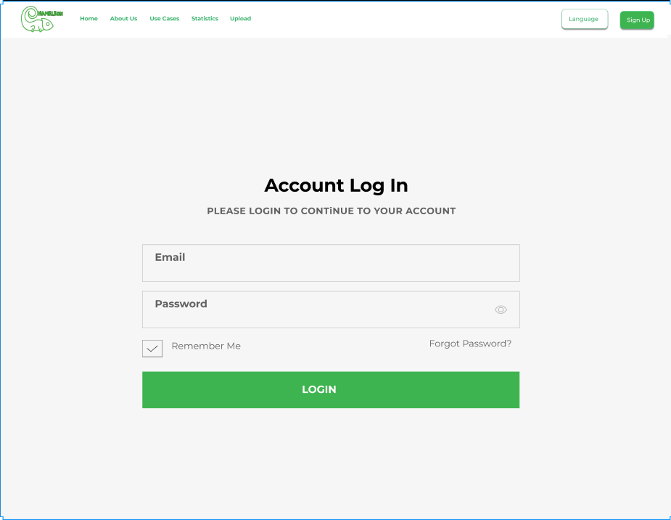**Details:**

* Account Login: 64px Bold/Montserrat (#000000)
* Please Iogin to Continue to your account: 32px Bold/ Montserrat (#616161)
* Text box labels: 36px Bold/Montserrat (#616161)
* Login Button colour: #3EB450
* Button text: 36px Bold/Montserrat (#FFFFFF)

**Dark theme:**

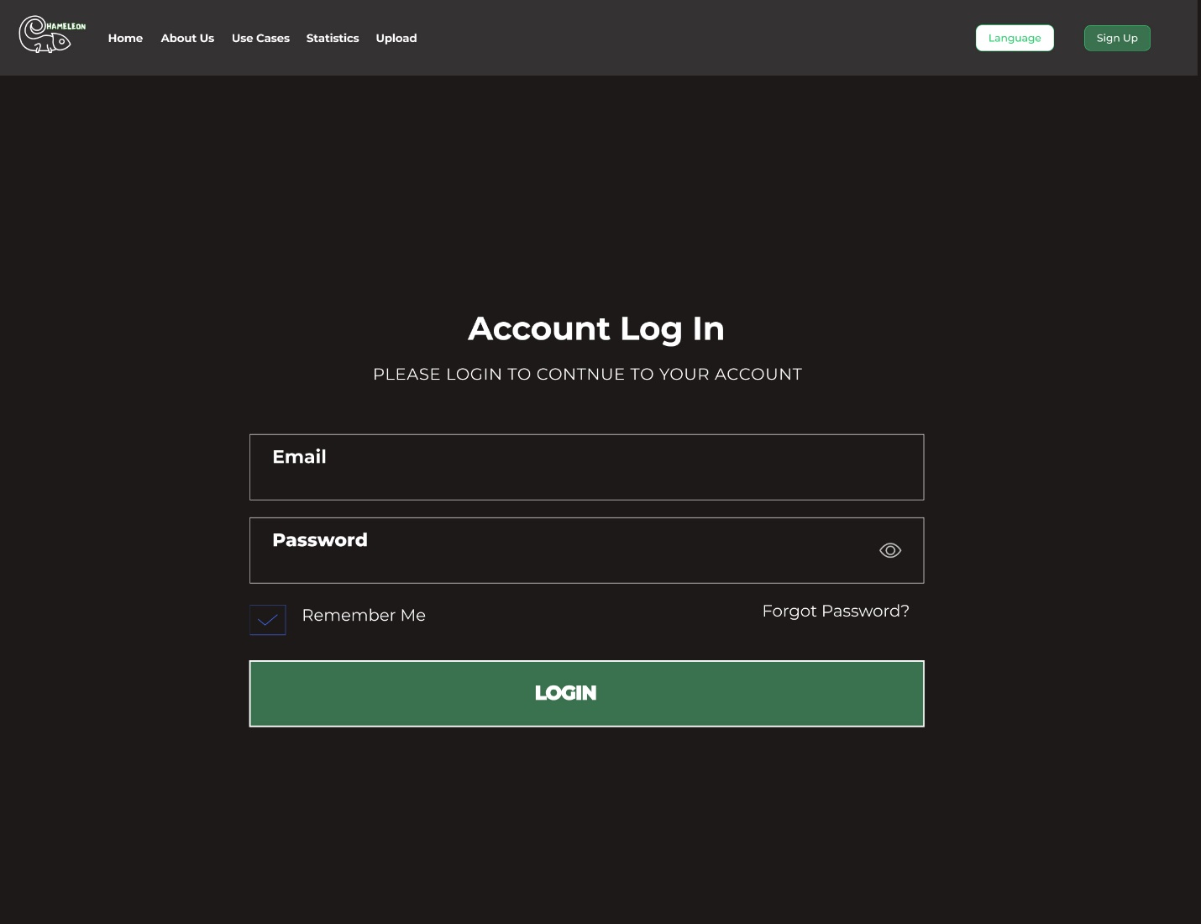**Details:**

* Account Login: 64px Bold/Montserrat (#FFFFFF)
* Please Iogin to Continue to your account: 32px Bold/ Montserrat (#FFFFFF)
* Text box labels: 36px Bold/Montserrat (#FFFFFF)
* Login Button colour: #3A714E
* Button text: 36px Bold/Montserrat (#FFFFFF)

**Sign Up Page:**

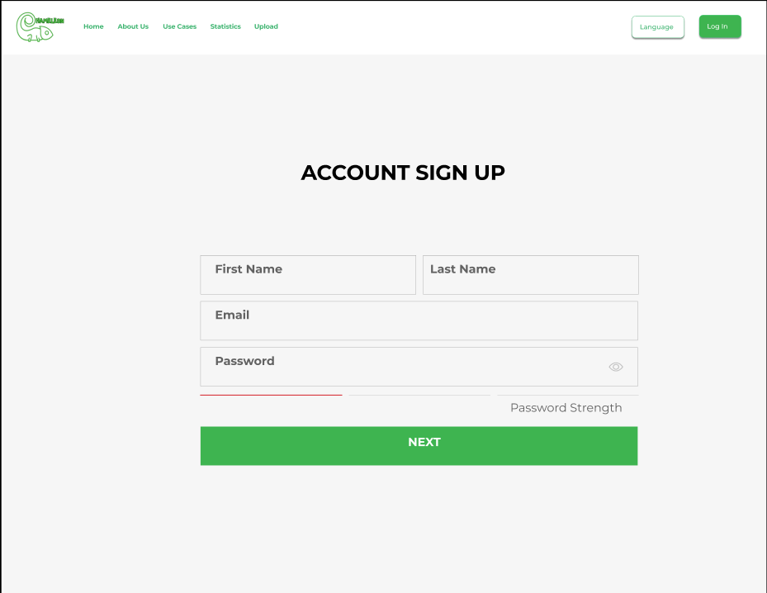

**Details:**

* Account Signup: 64px Bold/Montserrat (#000000)
* Text box labels: 36px Bold/Montserrat (#616161)
* Login Button colour: #3EB450
* Button text: 36px Bold/Montserrat (#FFFFFF)

**Dark Theme:**

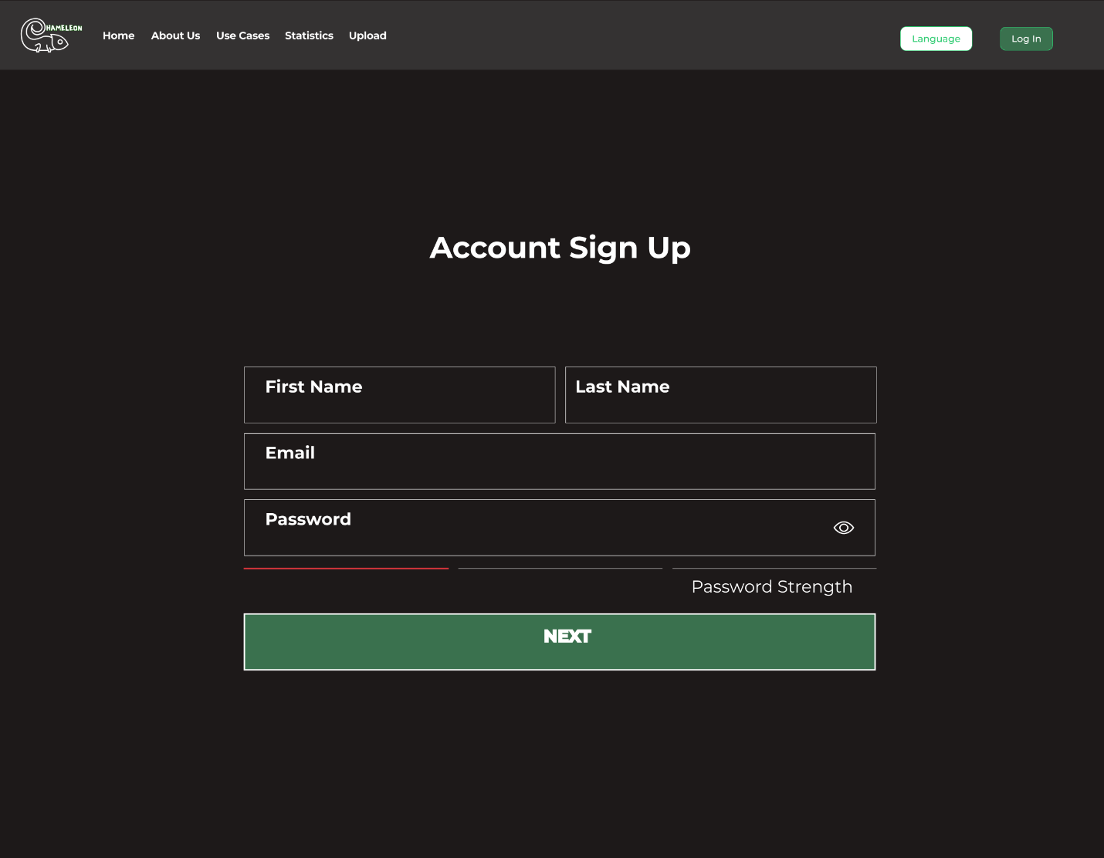

**Details:**

* Account Signup: 64px Bold/Montserrat (#FFFFFF)
* Text box labels: 36px Bold/Montserrat (#FFFFFF)
* Login Button colour: #3A714E
* Button text: 36px Bold/Montserrat (#FFFFFF)

Mobile View:

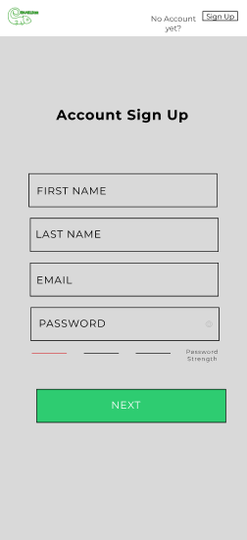

**Font Details:**

**OTP Verification**

* Font Size: 22
* Font type: Montserrat Bold
* Line Hight: 27
* Letter spacing: 1px
* Description font size: 14 Montserrat Regular.

**Input box text**

* Font Size: 16
* Font type: Montserrat Regular
* Line Hight: 20
* Font color: 000000
* Opacity: 100%

**Password strength**

* Font Size: 9
* Font Type: Montserrat Light
* Font color: 000000

**Button Details:**

* Button color: 2ECC71
* Button Size: 305.52 x 49.38
* Corner Radius: 9
* Text font: Montserrat Regular 16
* Text color: FFFFFF

**Forgot Password Page:**

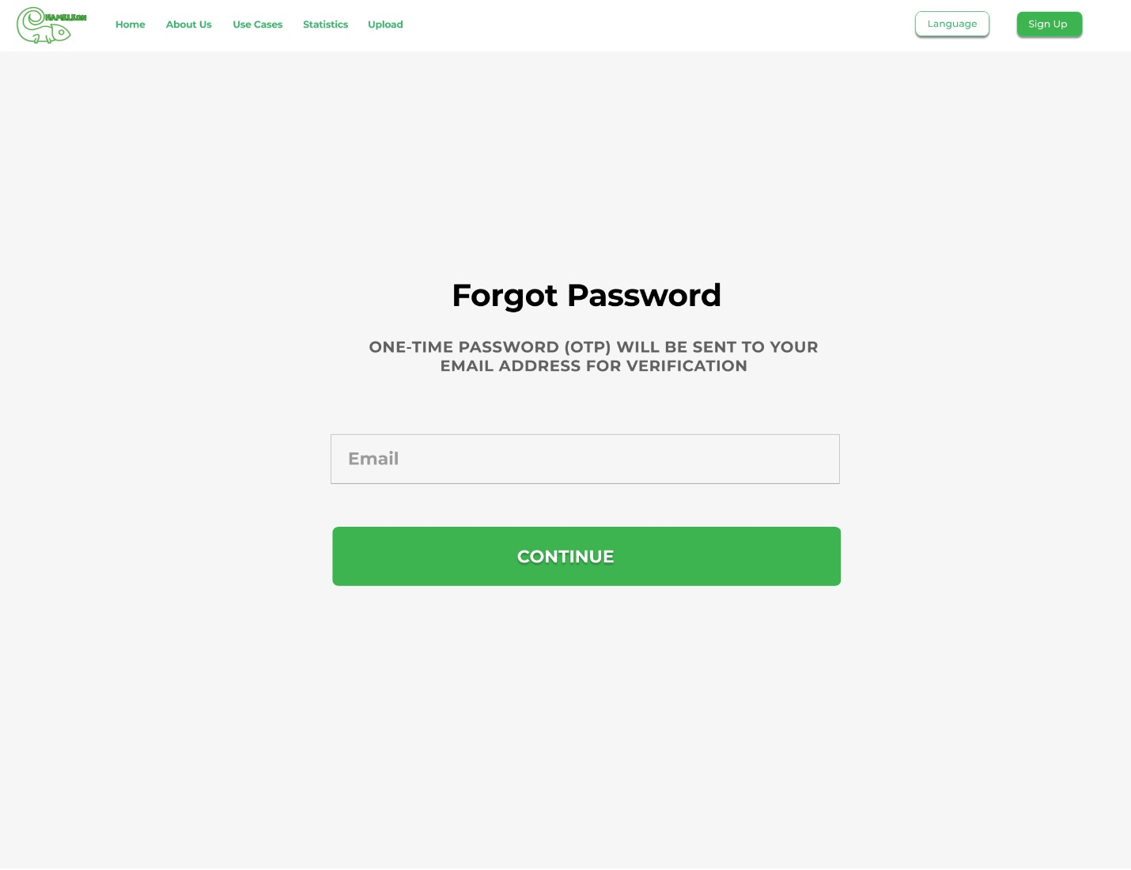

**Font Details:**

**Forgot Password**

* Font Size: 64
* Font type: Montserrat Bold
* Line Hight: 44
* Letter spacing: -0.5px
* Description font size: 32 Montserrat Bold.

**Email (input box text)**

* Font Size: 36
* Font type: Montserrat Bold
* Line Hight: 22.5
* Font color: 616161
* Opacity: 60%

**Button Details:**

* Button color: 3EB450
* Button Size: 1052x122
* Corner Radius: 12
* Text font: Montserrat Bold 36
* Text color: FFFFFF

**Dark Mode:**

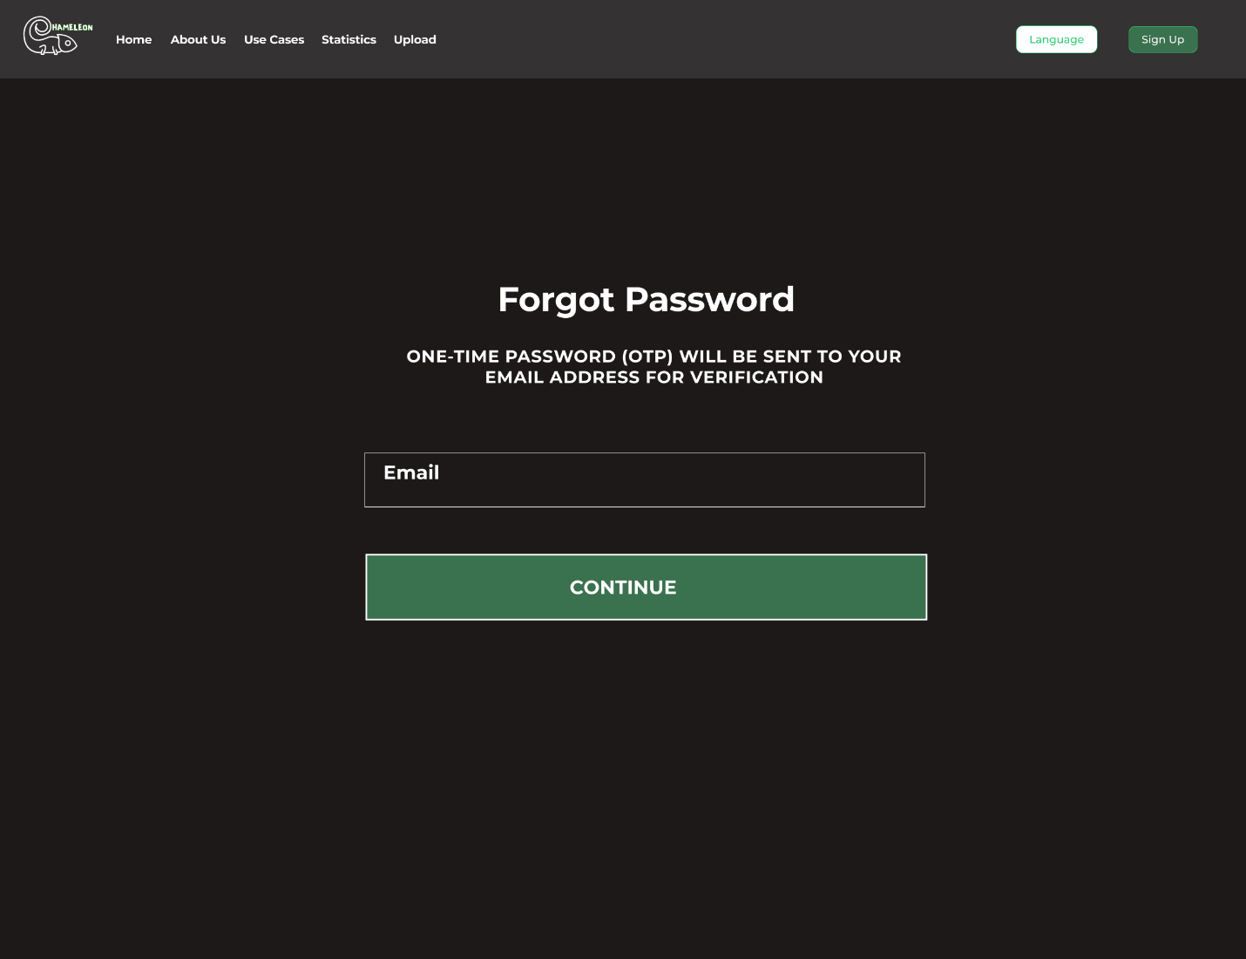

**Font Details:**

**Background color:1D1919**

**Forgot Password**

* Font Size: 64
* Font type: Montserrat Bold
* Line Hight: 44
* Letter spacing: -0.5px
* Description font size: 32 Montserrat Bold.

**Email (input box text)**

* Font Size: 36
* Font type: Montserrat Bold
* Line Hight: 22.5
* Font color: 616161
* Opacity: 60%

**Button Details:**

* Button color: 3A714E
* Button Size: 1052x122
* Corner Radius: 12
* Text font: Montserrat Bold 36
* Text color: FFFFFF

**Mobile View:**

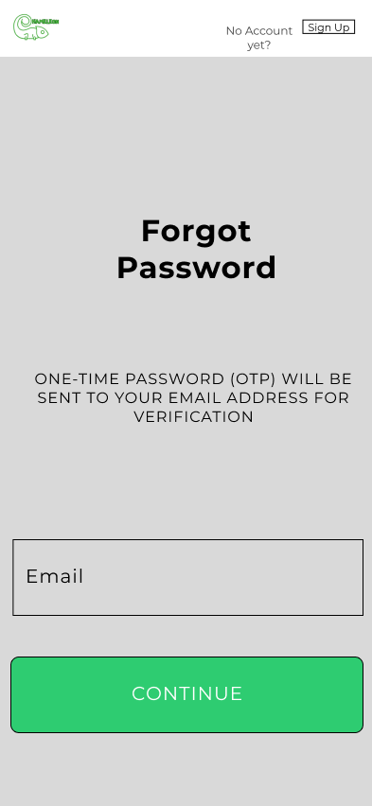

**Font Details:**

**Forgot Password**

* Font Size: 32
* Font type: Montserrat Bold
* Line Hight: 39
* Letter spacing: 1px
* Description font size: 16 Montserrat Regular.

**Email (input box text)**

* Font Size: 20
* Font type: Montserrat Regular
* Line Hight: 24
* Font color: 000000
* Opacity: 100%

**Button Details:**

* Button color: 2ECC71
* Button Size: 373 x 81
* Corner Radius: 9
* Text font: Montserrat Regular 20
* Text color: FFFFFF

**OTP Verification Page**

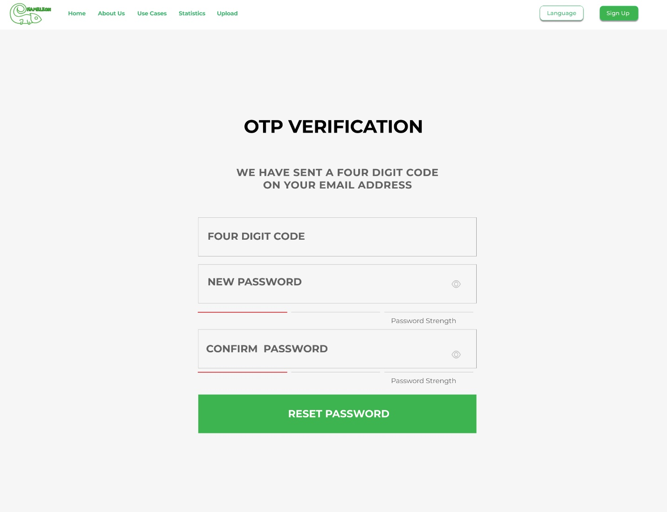

**Font Details:**

**OTP Verification**

* Font Size: 64
* Font type: Montserrat Bold
* Line Hight: 44
* Letter spacing: -0.5px
* Description font size: 32 Montserrat Bold.

**Input box text**

* Font Size: 36
* Font type: Montserrat Bold
* Line Hight: 22.5
* Font color: 616161
* Opacity: 60%

**Password strength**

* Font Size: 24
* Font Type: Montserrat Regular
* Font color: 616161

**Button Details:**

* Button color: 3EB450
* Button Size: 976.02x135.82
* Corner Radius: 12
* Text font: Montserrat Bold 36
* Text color: FFFFFF

**Dark Mode:**

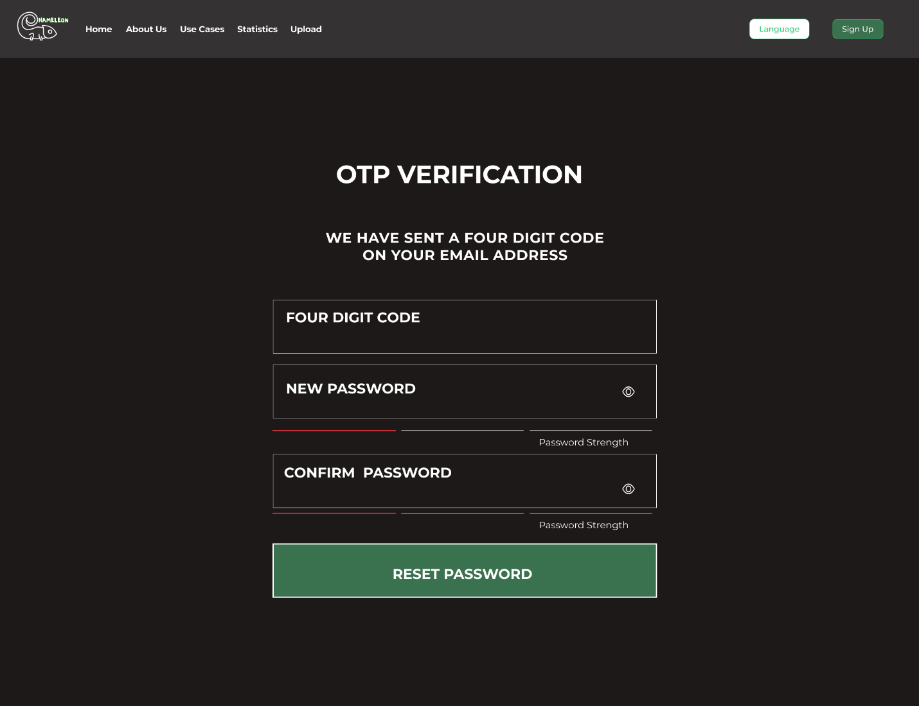

**Font Details:**

**Background color:1D1919**

**OTP Verification**

* Font Size: 64
* Font type: Montserrat Bold
* Line Hight: 44
* Letter spacing: -0.5px
* Description font size: 32 Montserrat Bold.

**Input box text**

* Font Size: 36
* Font type: Montserrat Bold
* Line Hight: 22.5
* Font color: 616161
* Opacity: 60%

**Password strength**

* Font Size: 24
* Font Type: Montserrat Regular
* Font color: 616161

**Button Details:**

* Button color: 3A714E
* Button Size: 976.02x135.82
* Corner Radius: 12
* Text font: Montserrat Bold 36
* Text color: FFFFFF

**Mobile View:**

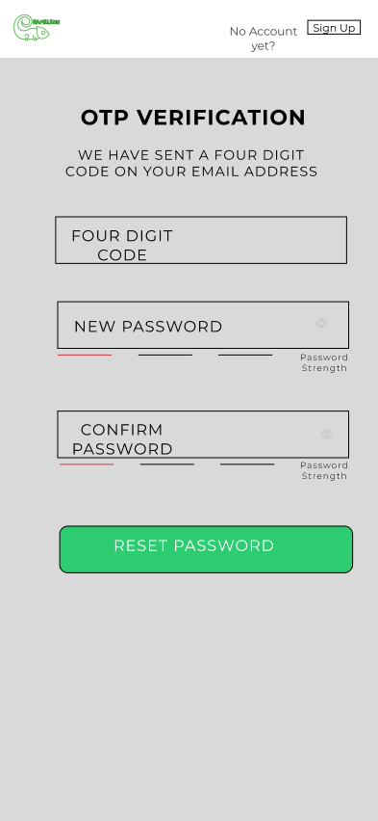

**Font Details:**

**OTP Verification**

* Font Size: 22
* Font type: Montserrat Bold
* Line Hight: 27
* Letter spacing: 1px
* Description font size: 14 Montserrat Regular.

**Input box text**

* Font Size: 16
* Font type: Montserrat Regular
* Line Hight: 20
* Font color: 000000
* Opacity: 100%

**Password strength**

* Font Size: 9
* Font Type: Montserrat Light
* Font color: 000000

**Button Details:**

* Button color: 2ECC71
* Button Size: 305.52 x 49.38
* Corner Radius: 9
* Text font: Montserrat Regular 16
* Text color: FFFFFF

**Conclusion**

This document serves as a comprehensive guide for future students tasked with updating or enhancing the Chameleon website. It provides detailed insights into the structural, functional, and visual aspects of the site, ensuring that any modifications align with the original design intent. For new students, it is crucial to understand the reasoning behind the design choices, such as the focus on user experience, visual hierarchy, and scalability. This document outlines the foundational elements, including wireframes, typography, color schemes, and layout considerations, offering a clear blueprint for maintaining the website’s consistency and integrity.

By following this guide, future students will be equipped with the knowledge necessary to make thoughtful and cohesive updates to the website, preserving its core design principles while allowing for innovation and improvement.

**Contributors**

This section recognizes the efforts of the design team, who collaboratively worked on the Chameleon website’s design. Each member contributed valuable expertise to various aspects of the design, ensuring a cohesive and user-friendly website.

1. Saiteja Ravella
2. Suraj Kuwar
3. Abhishek Chiluka
4. Ahmad Rahman
5. Tyler Sheaf
6. Radha Krishna Gampa
7. Akshit Sanjay Kawa
8. Jiaqi Li
9. Rajat Gupta
10. Shevin Mihindukulasuriya Patabedige